DEPT BAF
The Department of BAF and BMS had organized a webinar on Stock Market for SY/TY students. It was organized on 16th September, 2021 at 11:30 a.m. on Google meet platform. This webinar was chaired by Mr. Venkata Harsha who is Founder and Managing Director, Shine Projects. Approximately 95 students participated in the webinar.
The speaker shared about his expertise, skills and knowledge about stock exchange. He explained the difference between SENSEX & NIFTY. It was highly informative and interactive session.
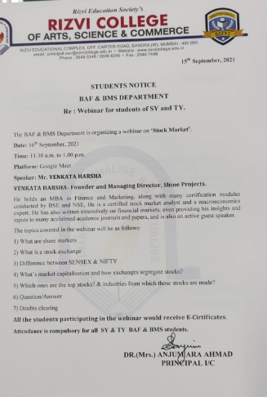

Webinar on Filing of Income Tax Returns
This webinar was conducted by BAF Department in collaboration with Commerce Association Committee for FY/SY/TY students .It was organized on 21st January, 2022 at 11:00 a.m. on Google meet platform. This webinar was chaired by Mr. Subhash Gupta (BAF Coordinator). Approximately 100 students participated in the webinar.
The speaker shared about his expertise, skills and knowledge about different forms related to IT returns filing. Sir showed practically how to file IT returns and gave detailed knowledge about the same. It was highly informative and interactive session.
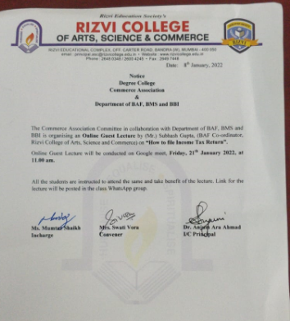

Webinar on Unlock Careers in Account and Finance through Skills.
This webinar was conducted by BMS, BAF and BBI Department in collaboration with ICA for FY/SY/TY students .It was organized on 31st January 2022 at 11:00 a.m. on Google meet platform. This webinar was chaired by CA Harish Kumar Vasandani who is associated with ICA (Bandra) as Centre Director. Approximately 90 students participated in the webinar.
The speaker shared about his expertise, skills and knowledge related with various software’s, applications, tools, and career options in this field. It was highly informative and interactive session.
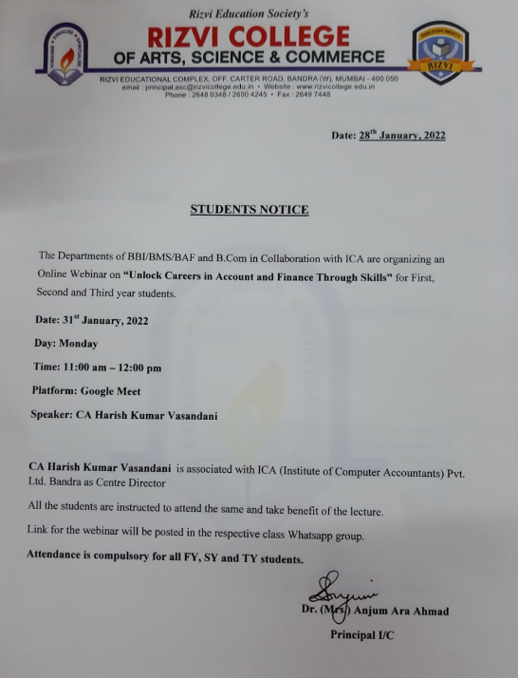

Webinar on Analysis of Components of Salary Slip
This webinar was conducted by BMS and BAF Department for FY/SY/TY students to make them aware about various components of salary slip received by employee. It was organized on 12th February 2022 at 2:00 p.m. on Google meet platform. This webinar was chaired by Mr. Satishkumar Sanku who is currently associated with Kotak Mahindra Bank as Deputy Manager (Human Resource). Approximately 90 students participated in the webinar.
The speaker emphasized on various aspects of HR and Financial areas of salary slip and discussed each component in detail.
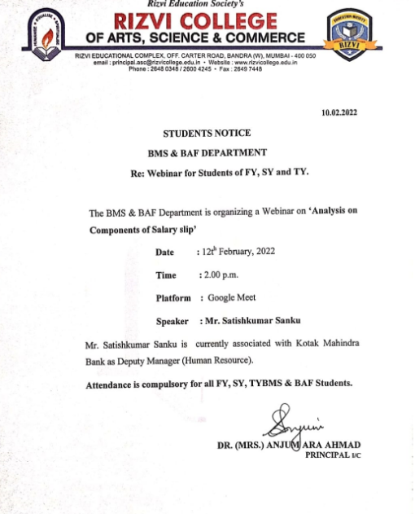

Webinar on Financial Literacy in Banking Sector
This webinar was conducted by BMS and BAF Department for FY/SY/TY students to make them aware about investment opportunities in Banking Sector on 15th February 2022 at 12:00 p.m. on Google meet platform. Approximately 85 students participated in the webinar. This webinar was chaired by Mr. Manohar Puranik, who is currently associated as Financial Education Counselor at ICICI Foundation for Inclusive Growth.
The speaker shared his knowledge about various aspects of financial areas of banking sector such as NPAs, investment opportunities, portfolio and encouraged students to inculcate saving habits amongst them.
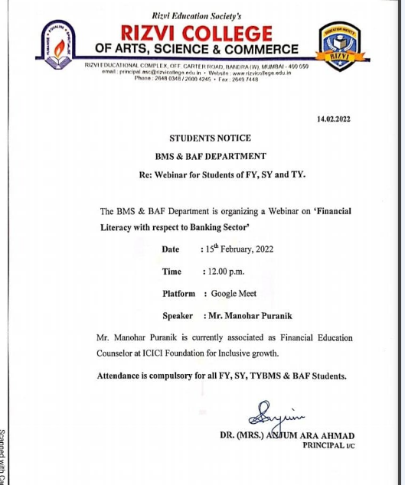

Webinar on Stand up against Street Harassment
This webinar was conducted by BMS and BAF Department for FY/SY/TY students to make them aware about the Street harassment on 17th February 2022 at 12:00 p.m. on Google meet platform. Approximately 90 students participated in the webinar. This webinar was chaired by Miss. Bisma Javed who is currently associated as a coordinator and trainer in Breakthrough India in association with Hollaback and L’Oreal Paris.
The speaker shared her knowledge and encouraged students to speak against any sort of street harassment by demonstrating the incidences via short clips and asked the participants about their queries and thoughts about it.
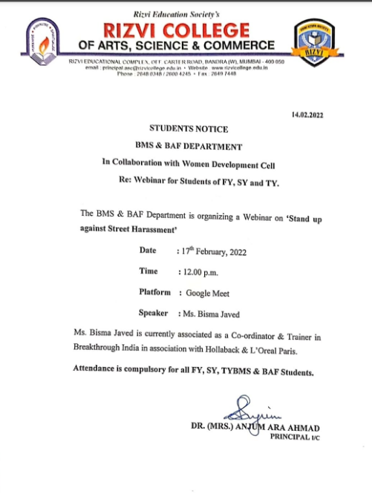

Short Term Course
The Department of BAF and BMS had organized Online Short Term Course on Tally with GST, Advance Excel and GST Return Filing in collaboration with Growmore Academy for 30 hours using Google Meet Platform. Advance Excel course commenced from 28th February, 2022 and completed on 13th March, 2022. Tally with GST course started from 21st March, 2022 and completed on 3rd April, 2022. GST Return Filing Course started from 1st April, 2022 and completed on 6th April, 2022.
42 students participated in the online course and had gained very good knowledge about Tally and Excel.

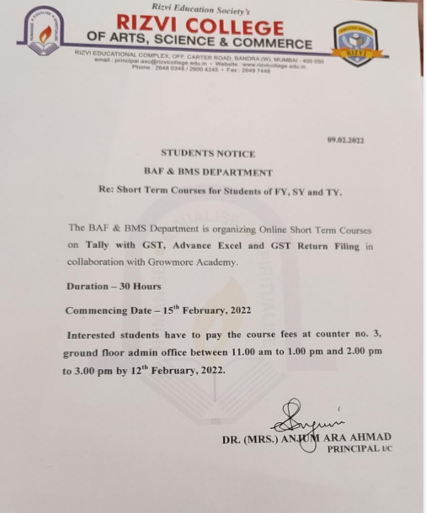

DEPT BBI

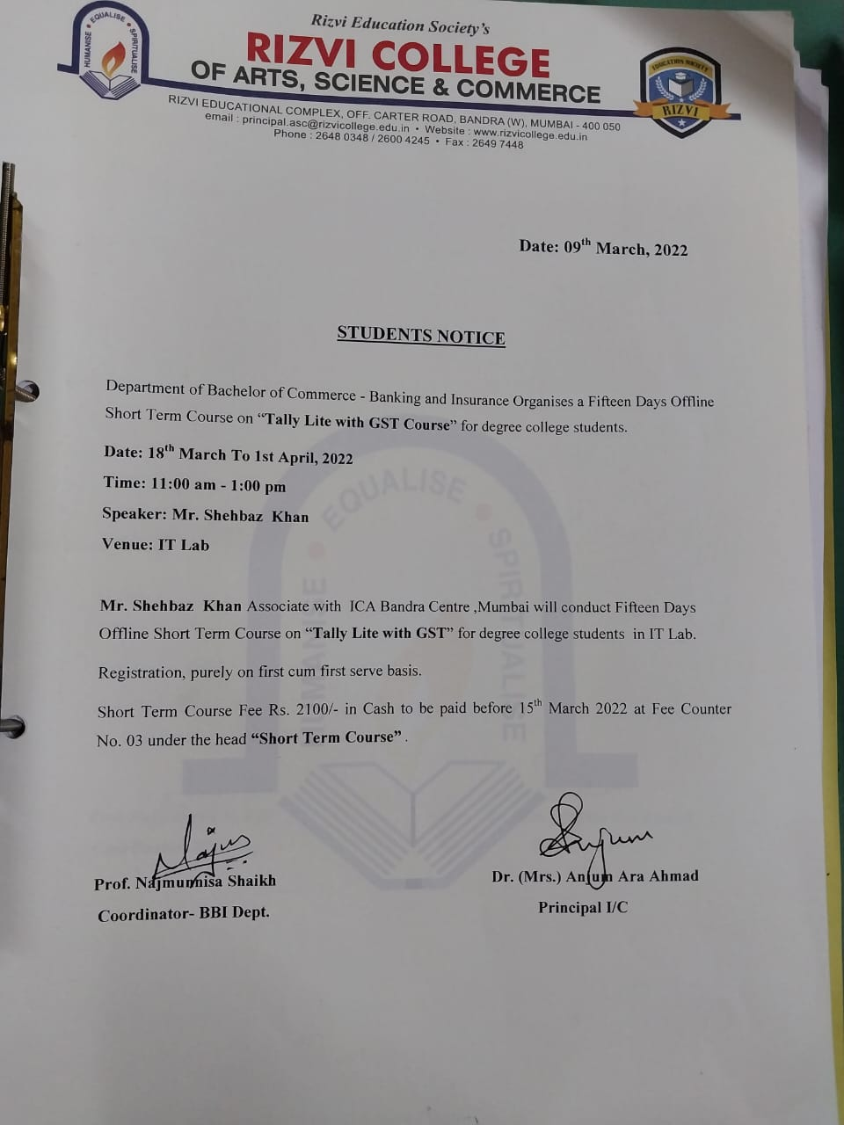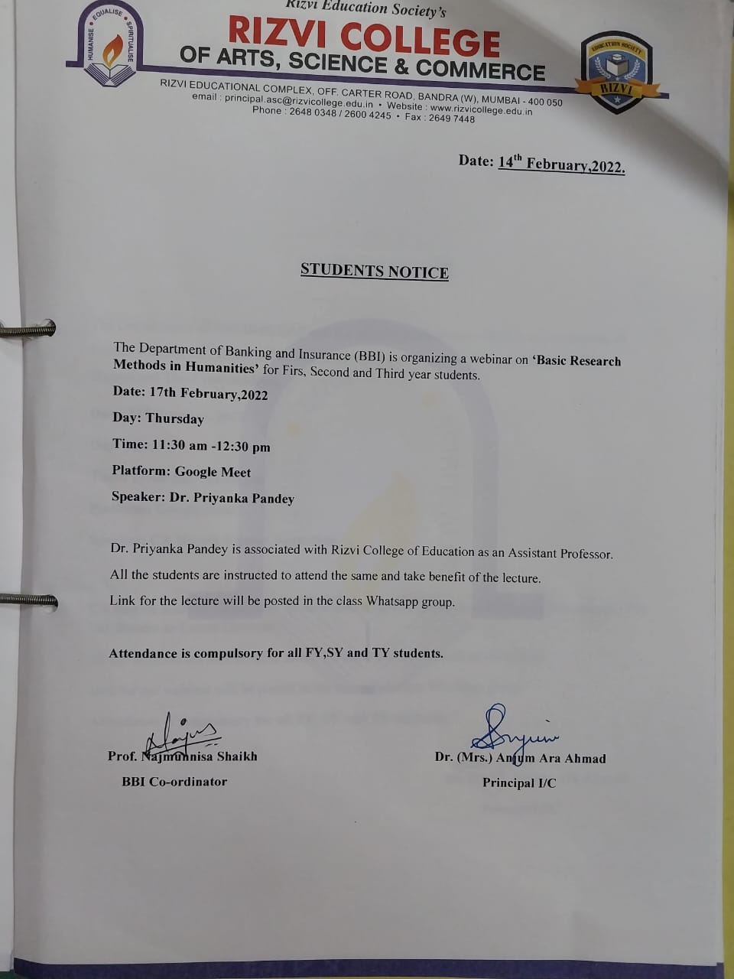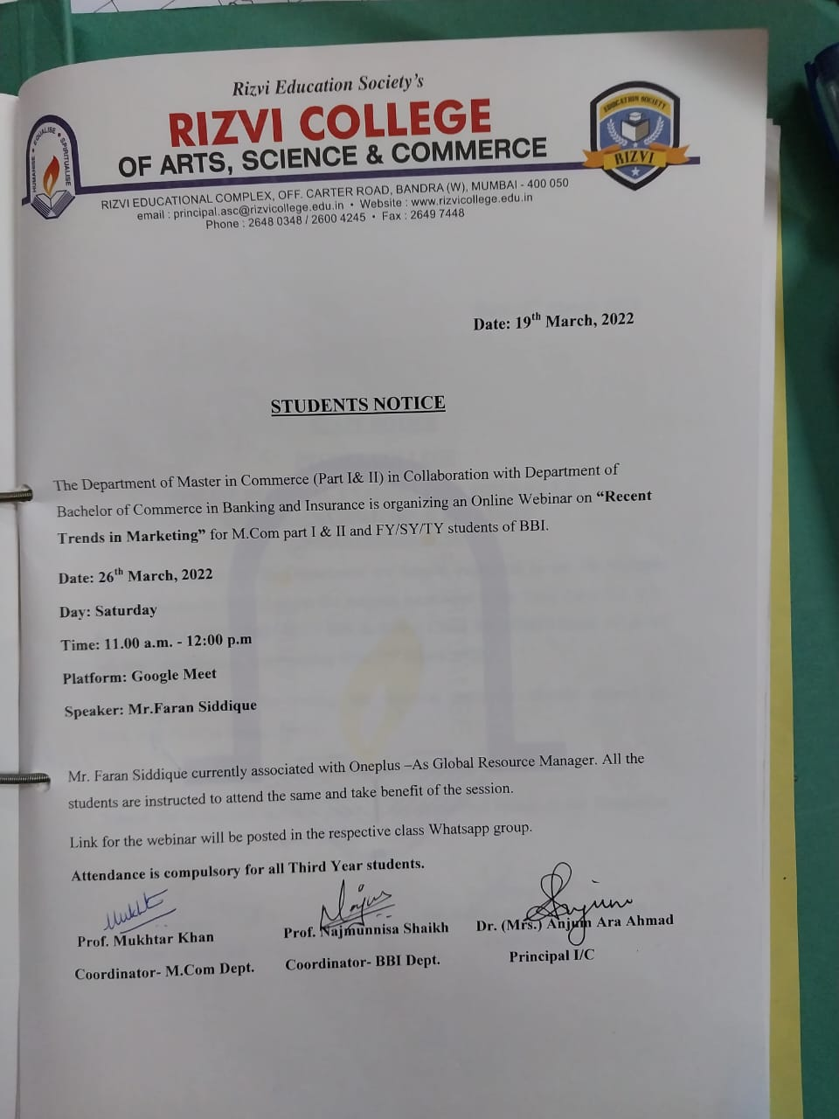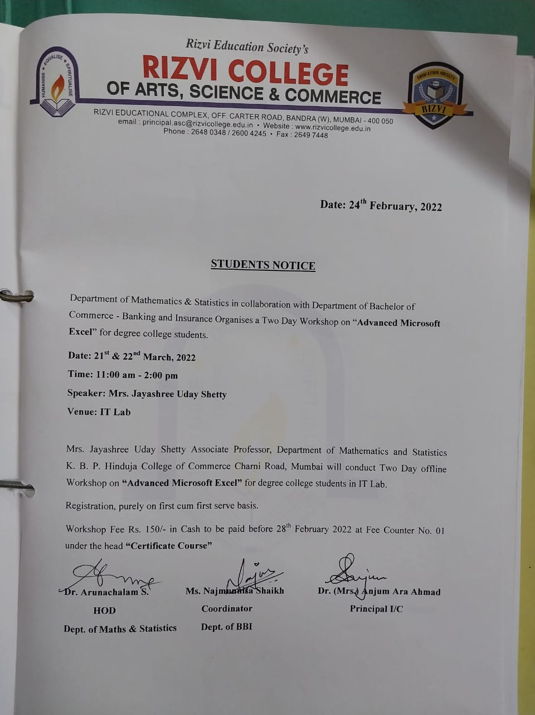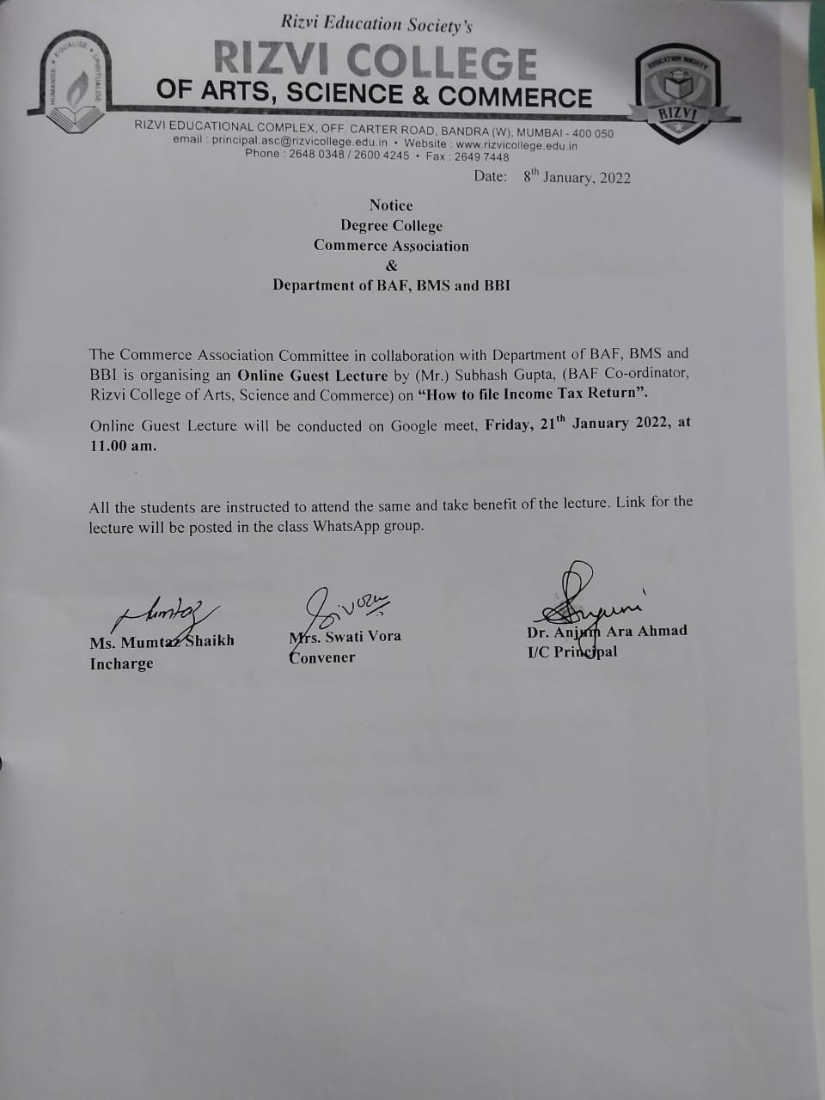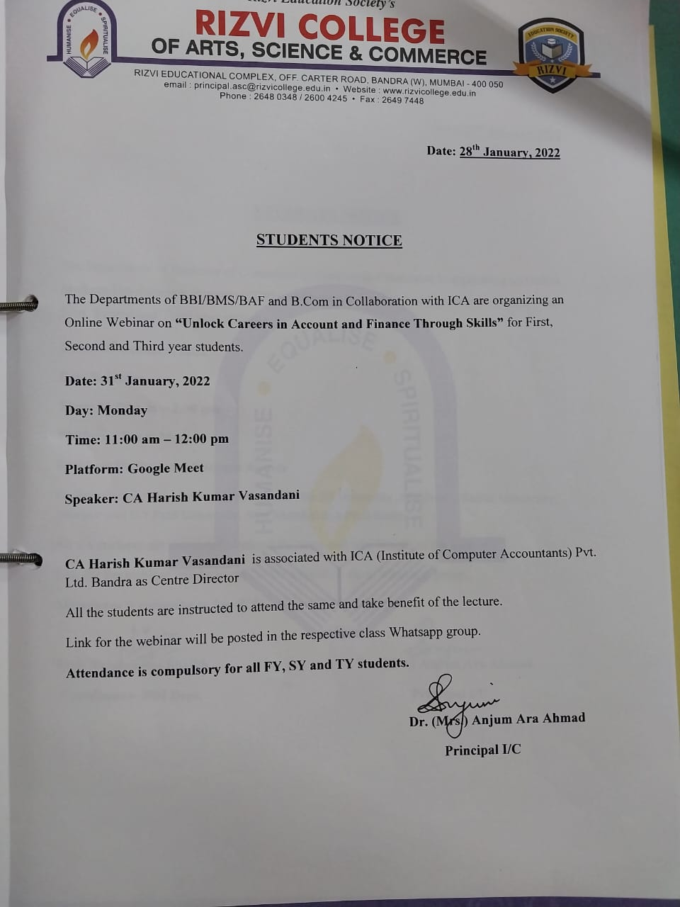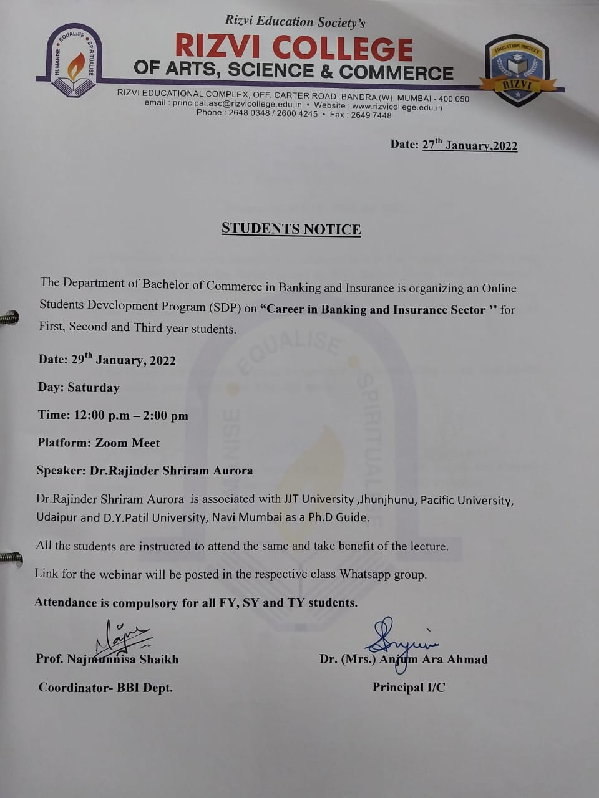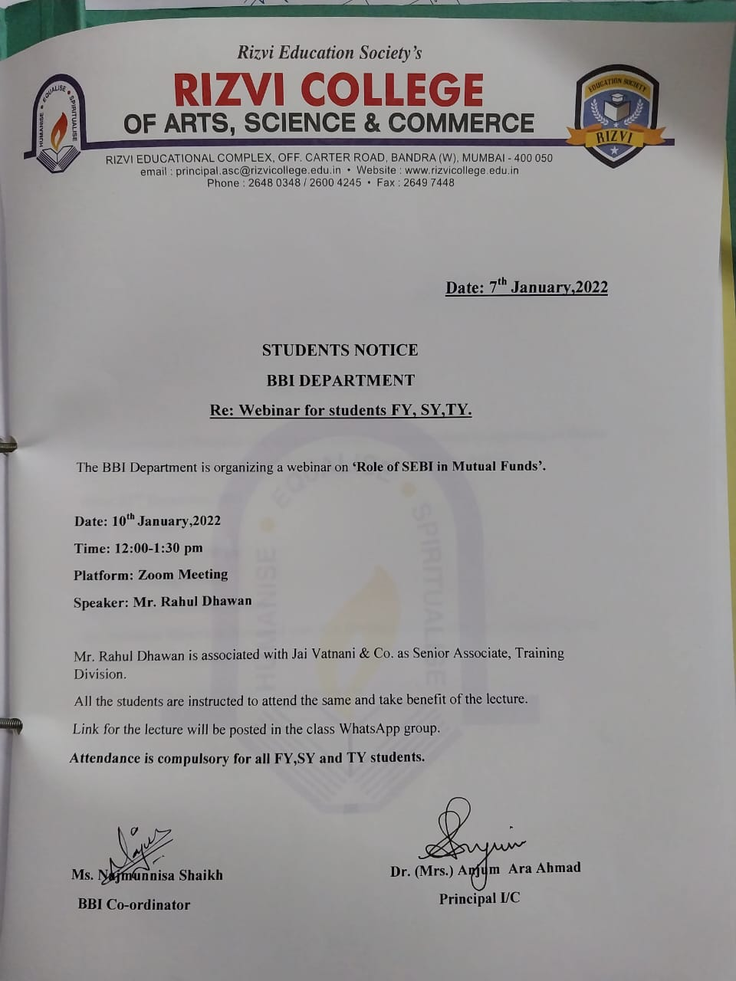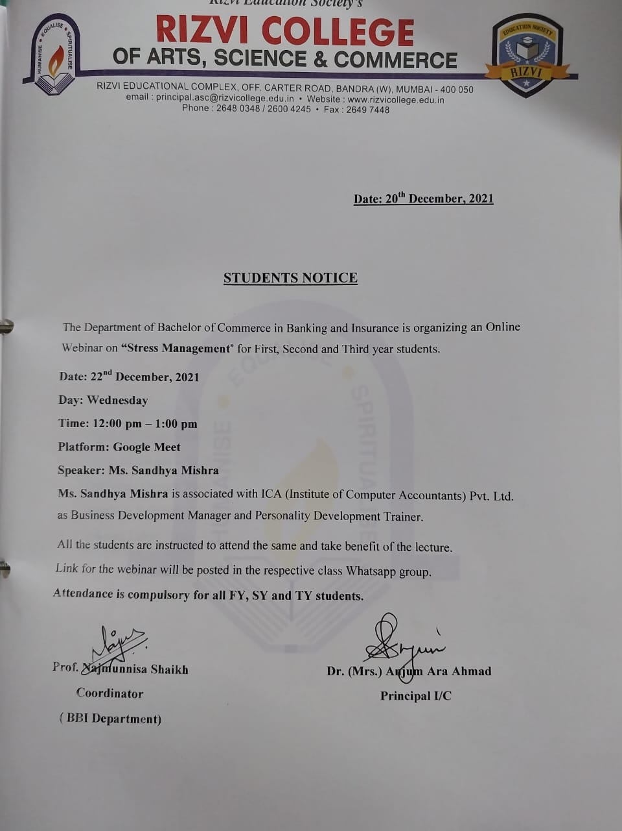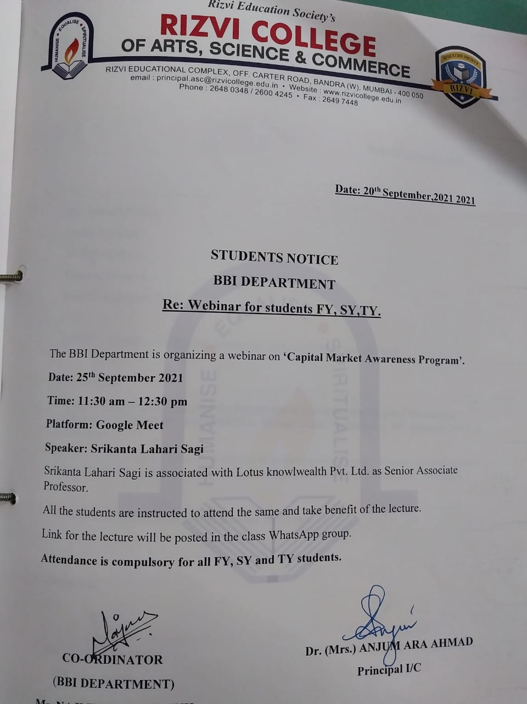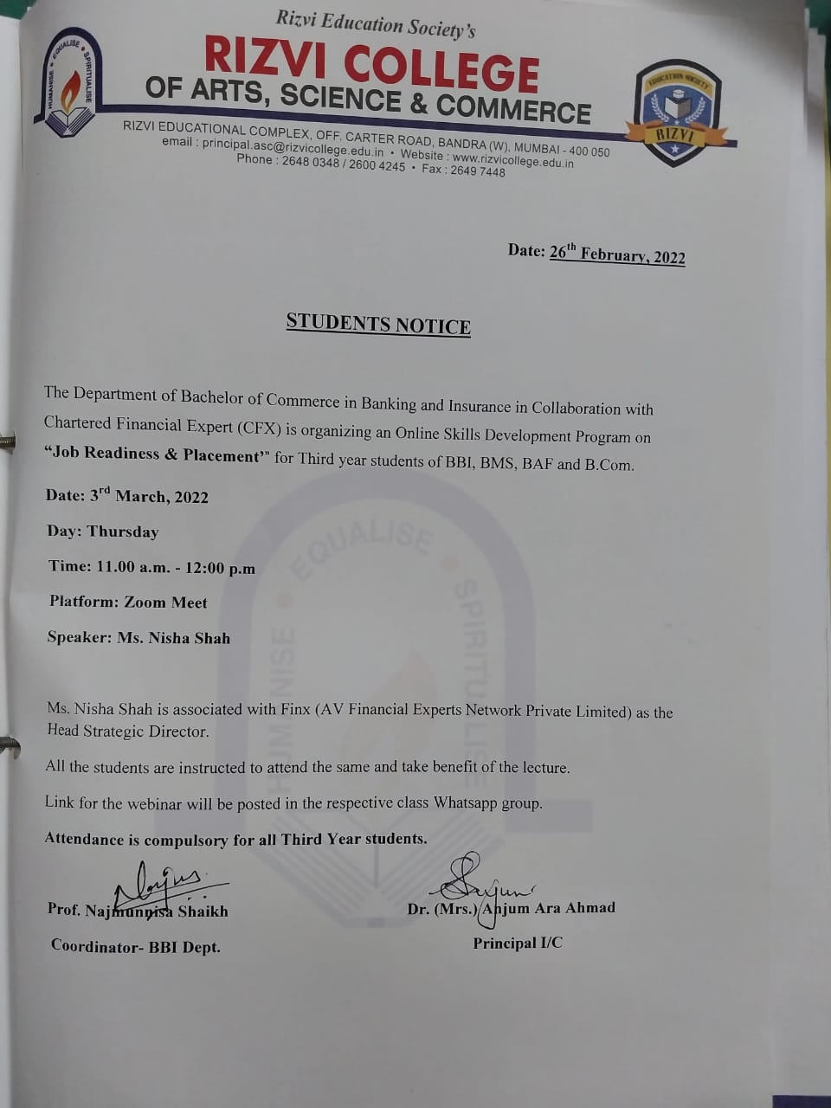

DEPT BMS

DEPT Chemistry
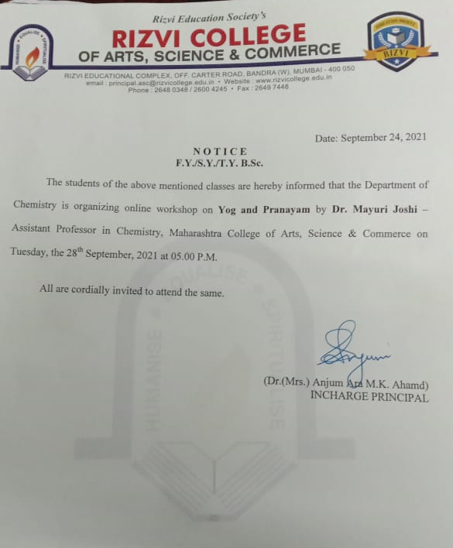

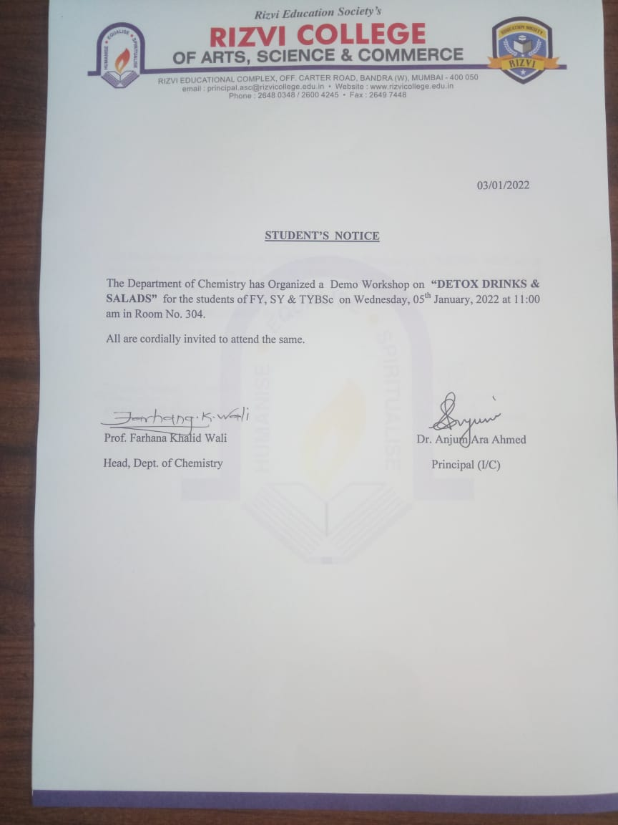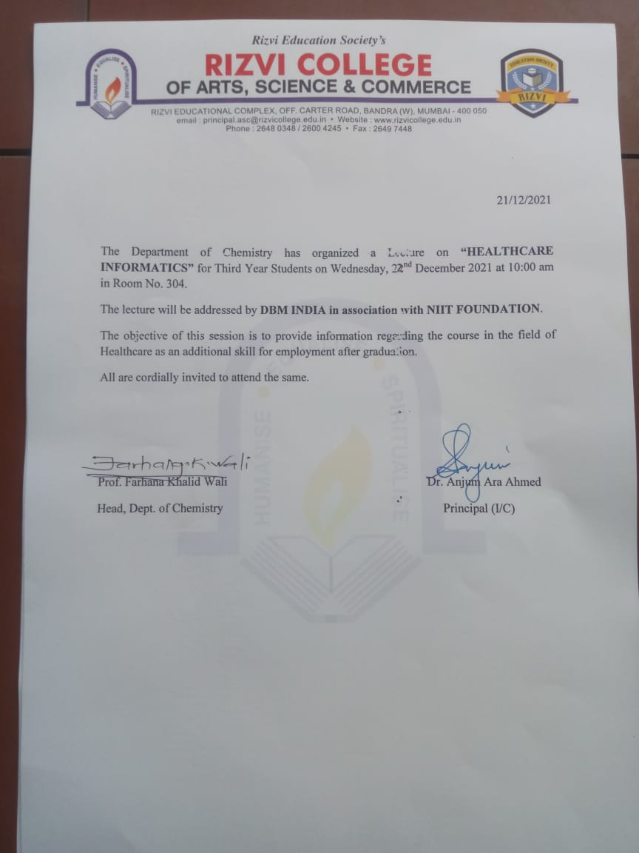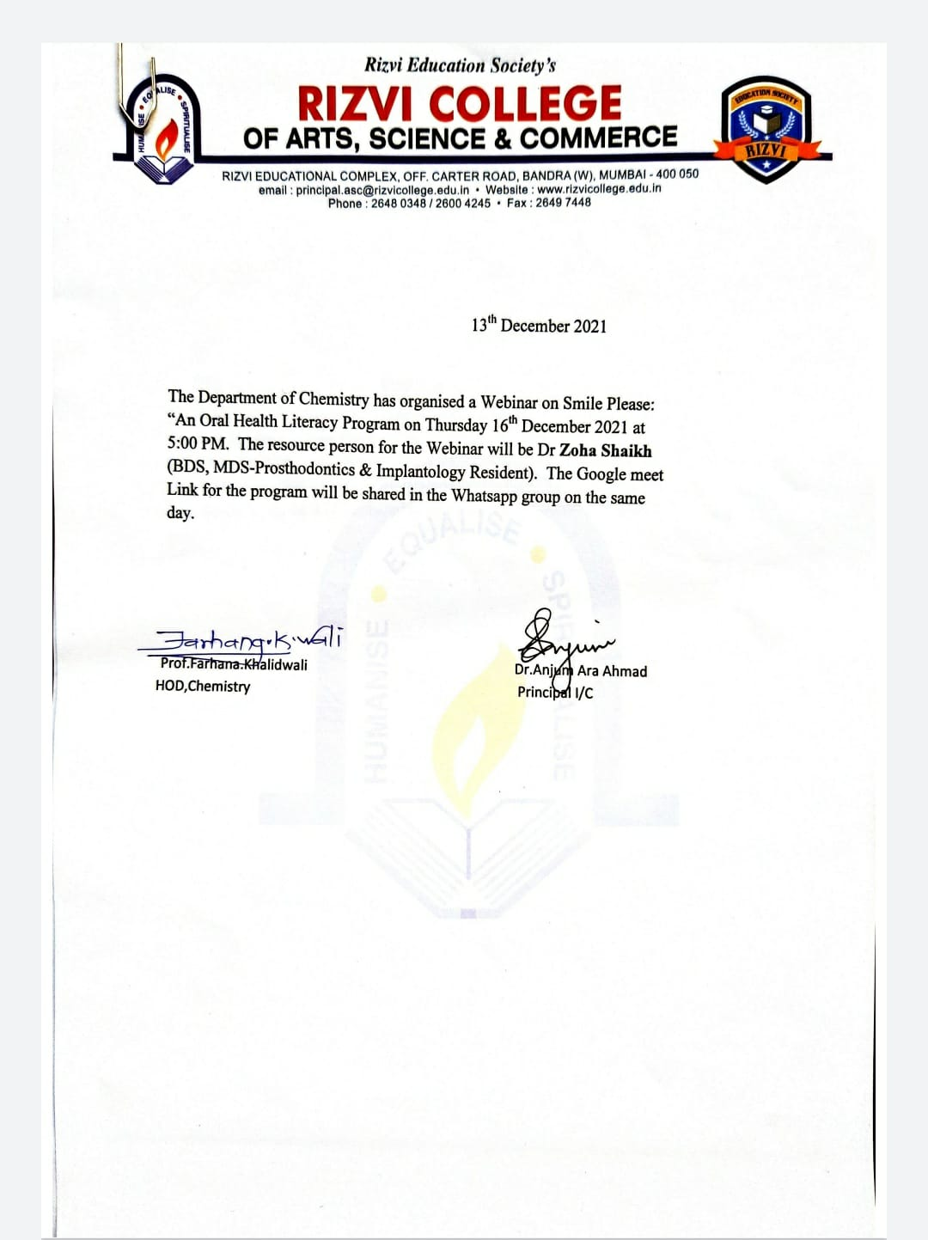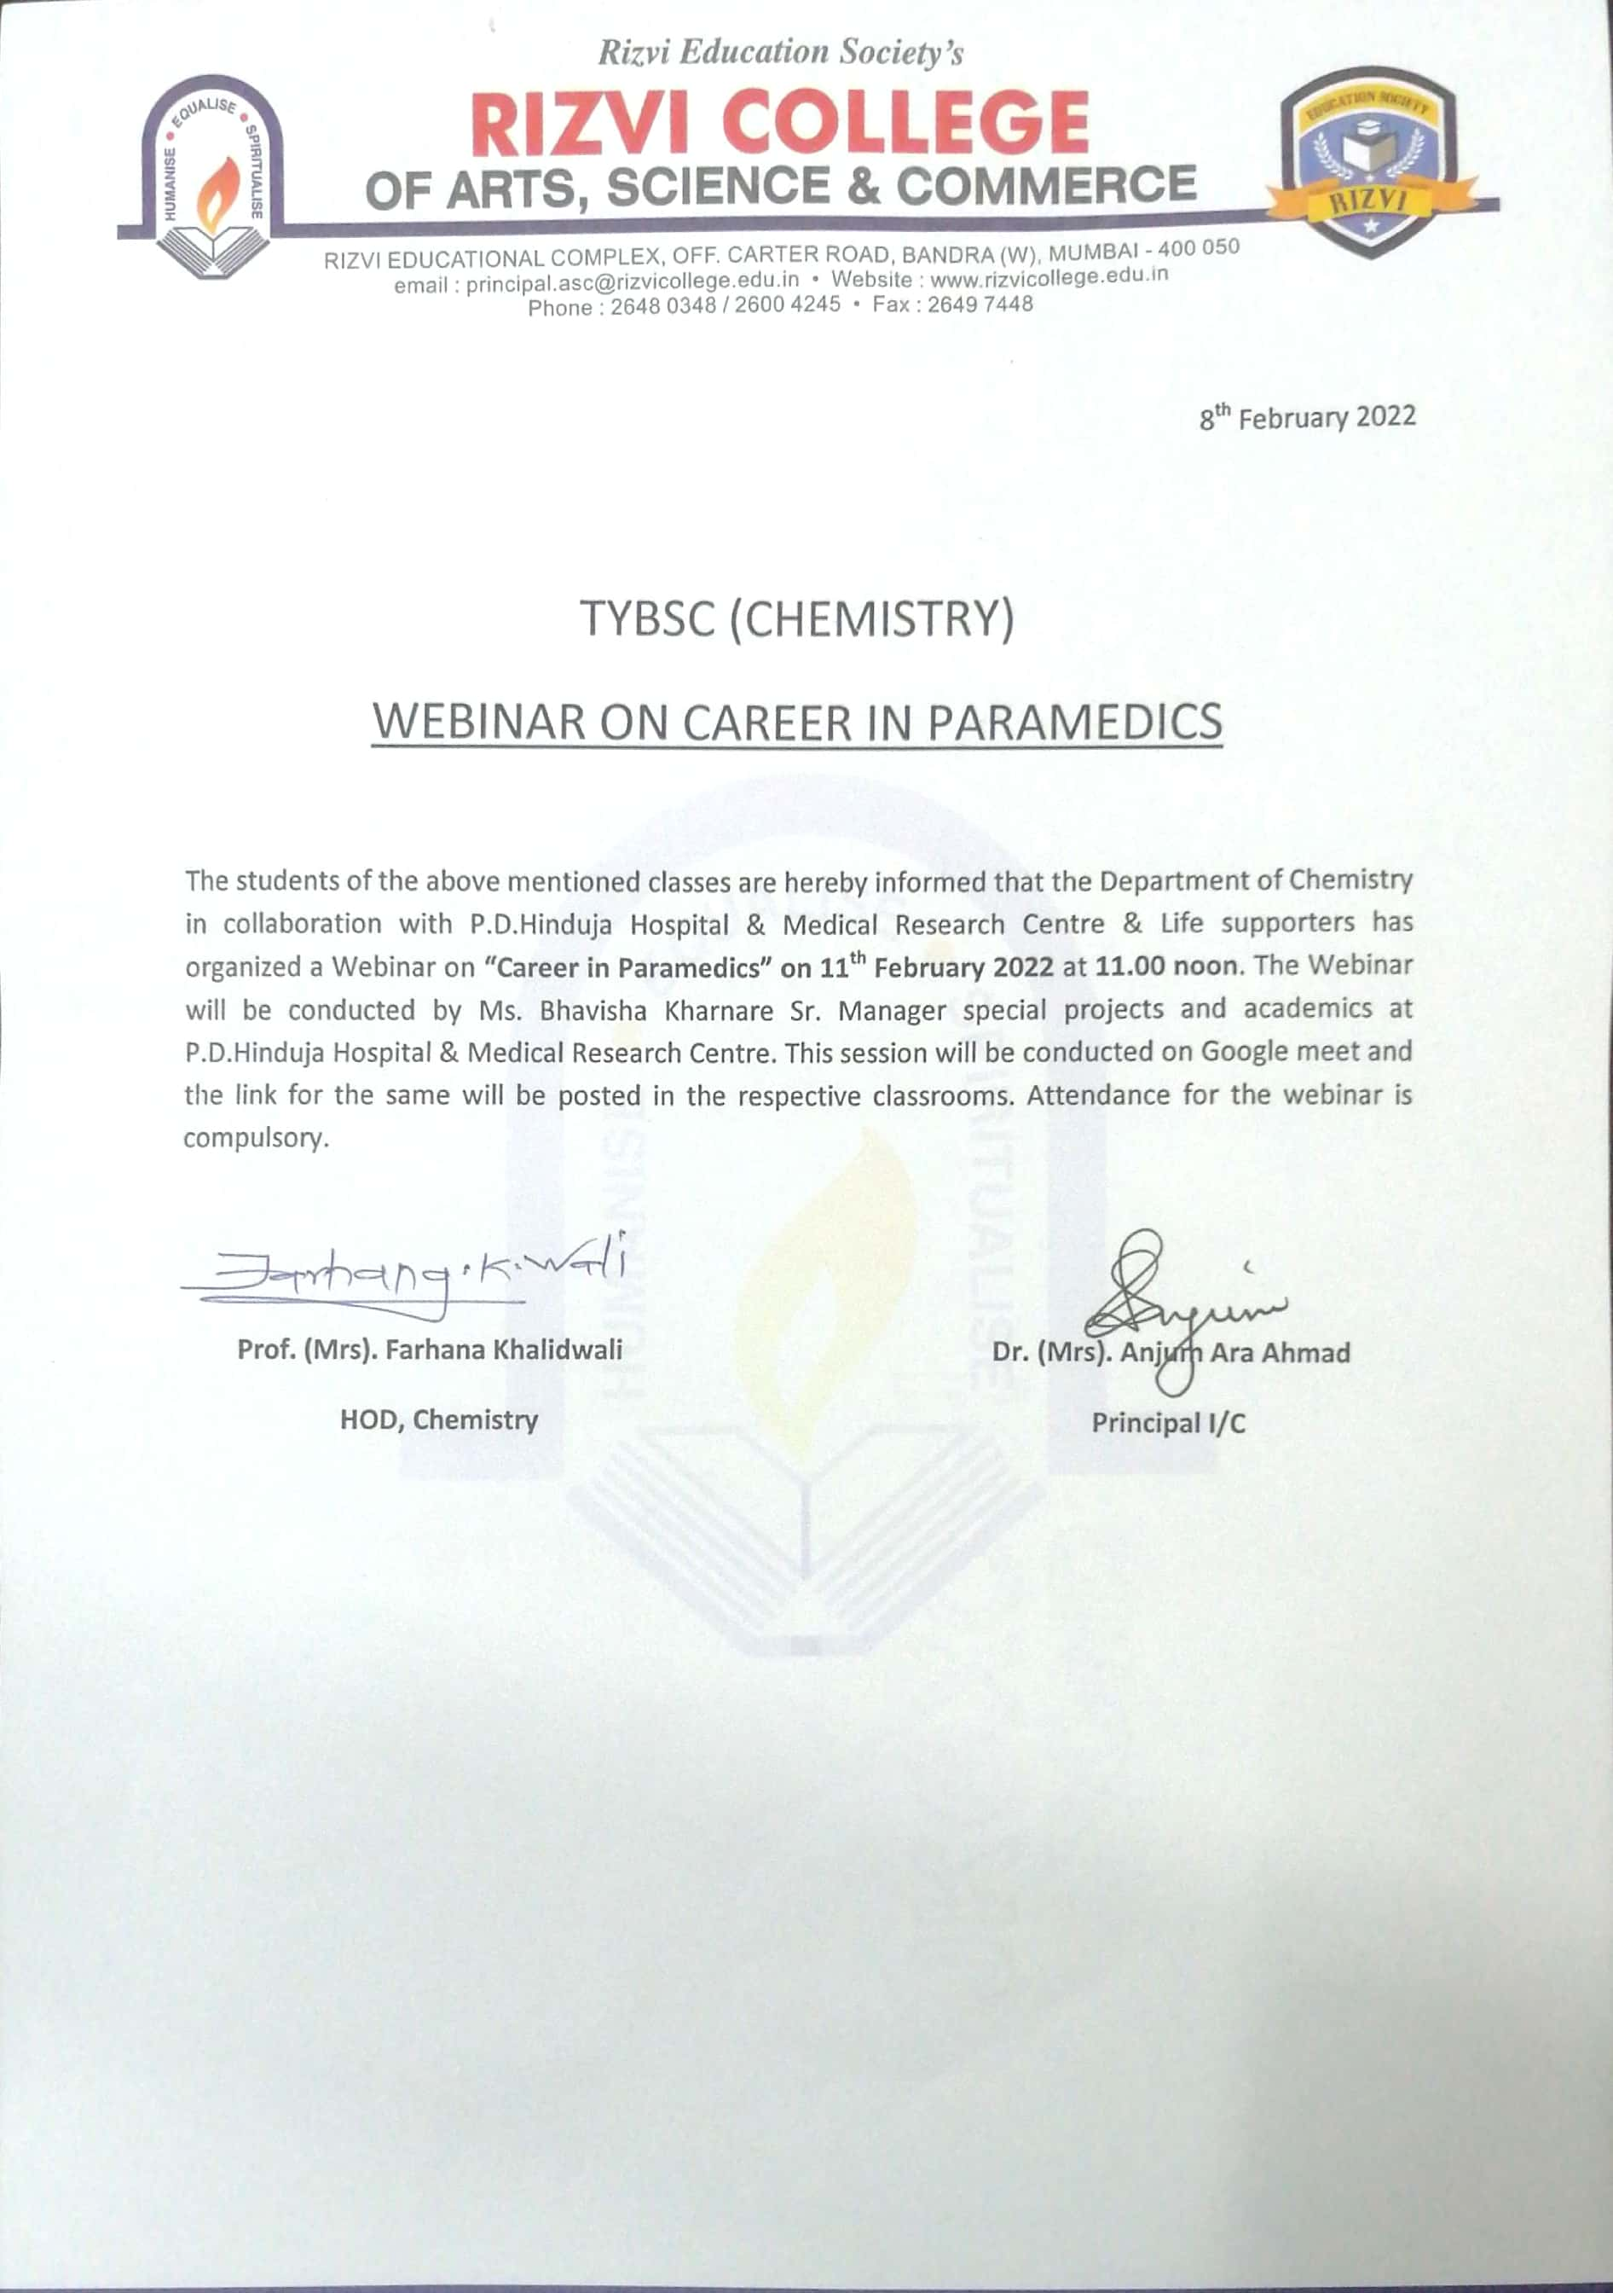

DEPT EVS
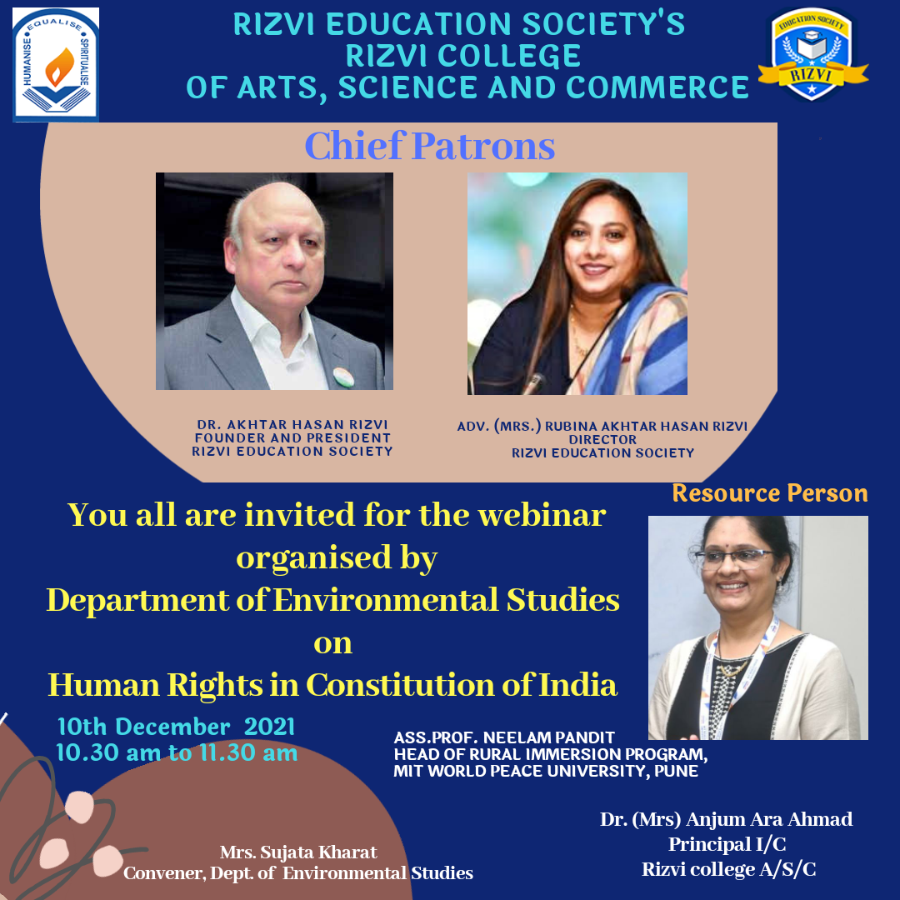
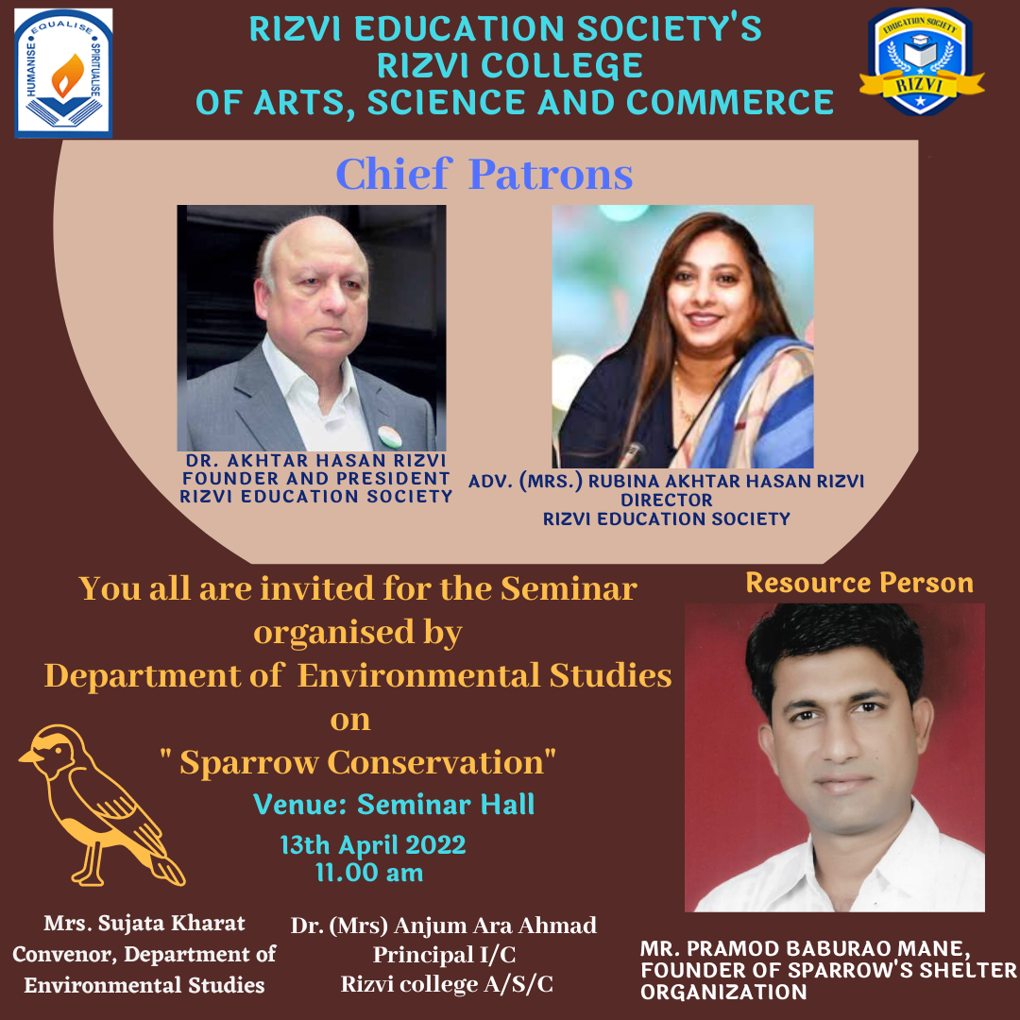

SEPT HINDI
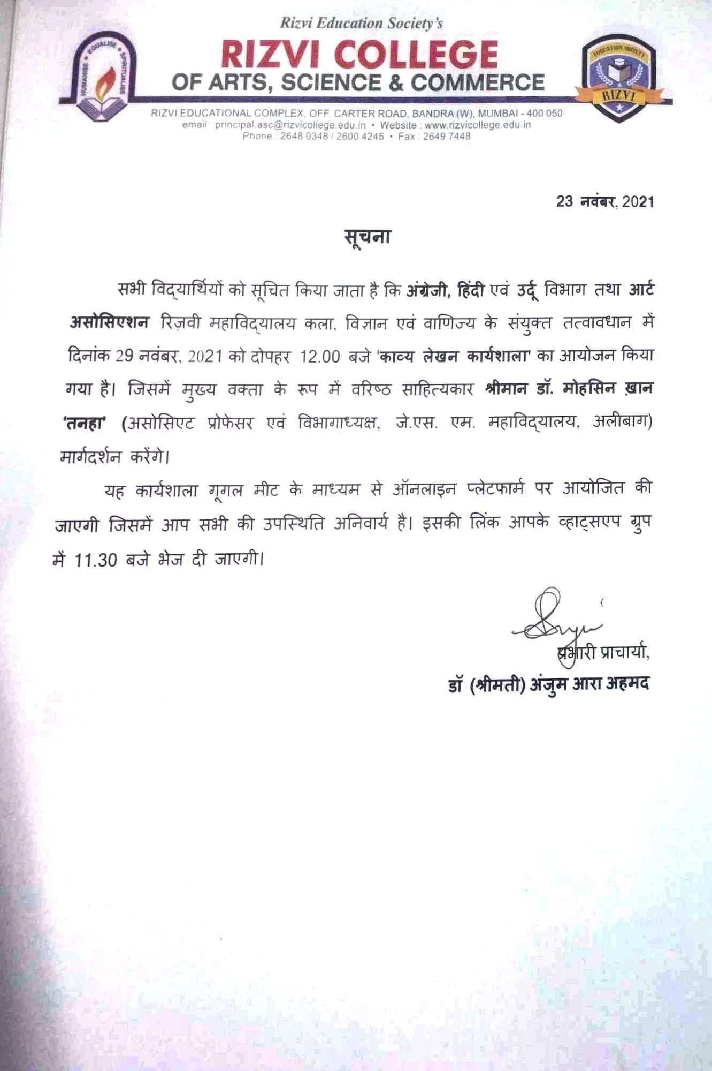
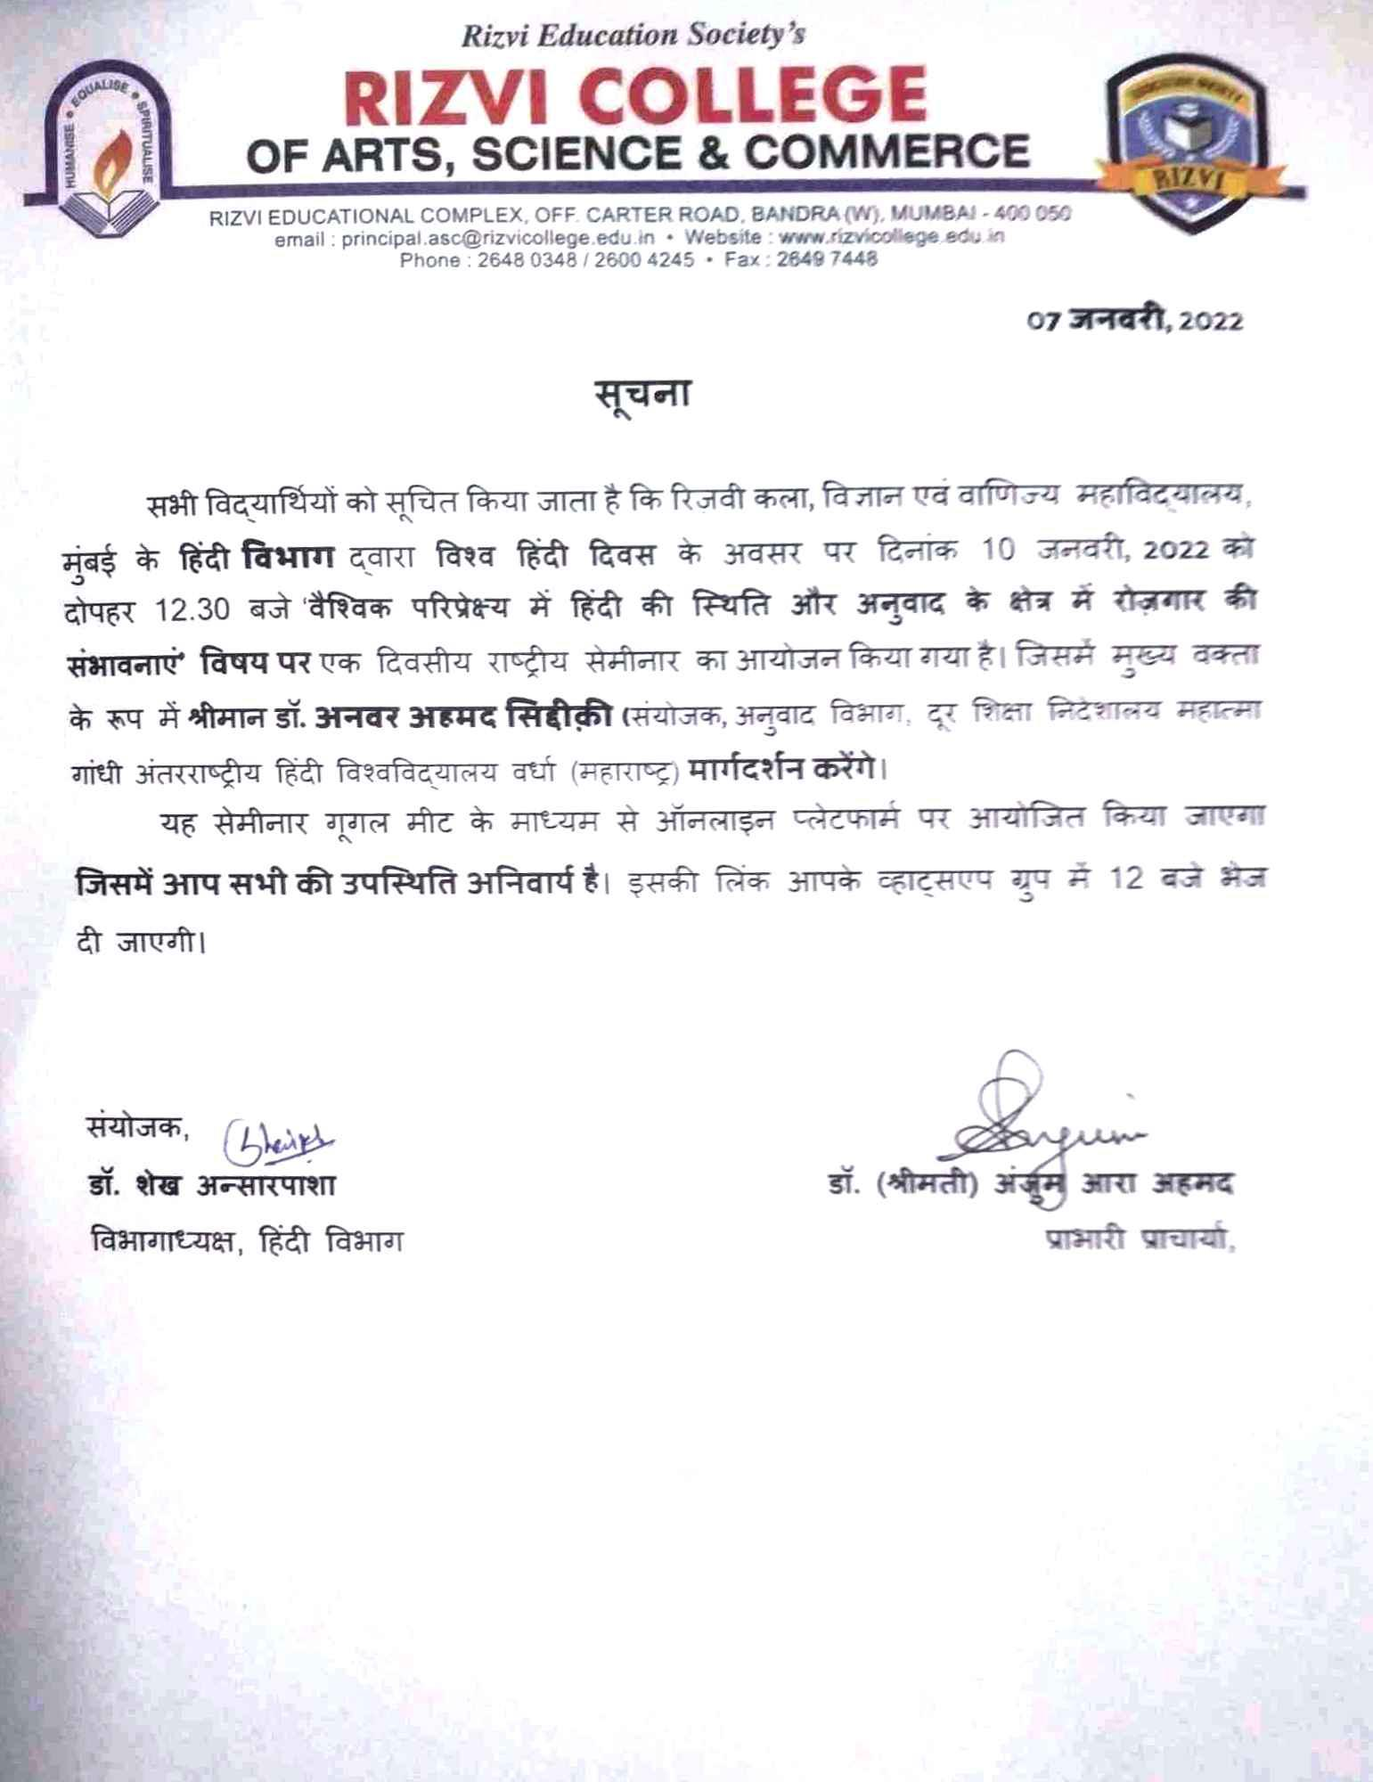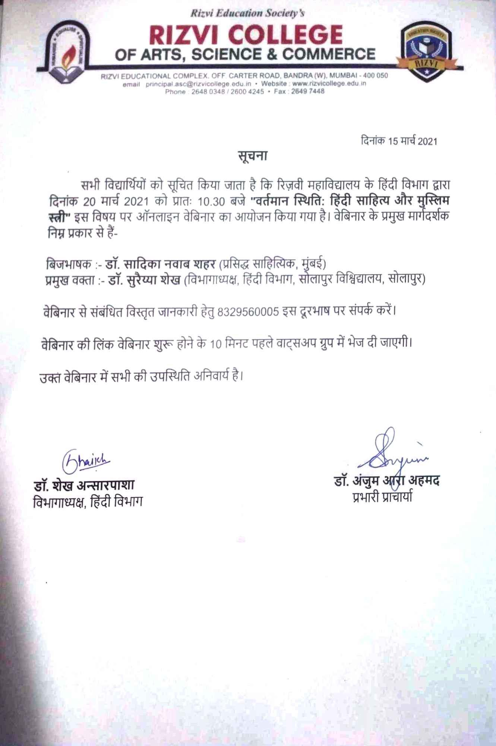

DEPT LIBRARY

Dr. Rizvi Digital Library and Research Cell organized an Online Lecture on " How to get your research published in academic journals: a step guide for you. " on 10th August, 2021 for Degree College teachers. A total of 29 participants attended the lecture which reflected on points to remember while preparing a manuscript of research article to calculating the impact factor of a particular journal and using it as a tool to understand the changing status of a journal in which we intend to publish our articles. Information on types of scholarly articles, process of publishing an article, the time it takes, the different reasons of rejections of an article was given to the teachers. This session was very beneficial considering the fact that now more weightage is being given to Research published by an institution.

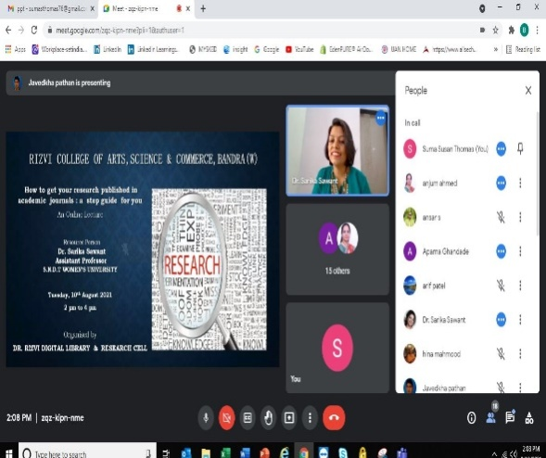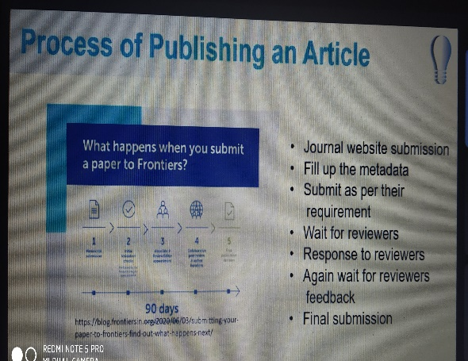

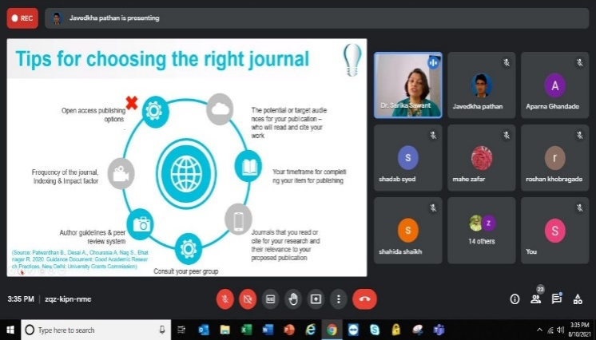

2) Online orientation program Guide to accessing NLIST e-resources and other academic e-resources"
4th October, 2021 ( 62 students )

Dr. Rizvi Digital Library in its efforts to promote e-learning and reading and to celebrate the birth anniversary of our former President Dr. APJ Abdul Kalam, organised an online orientation program for second year and third year students on 4th October 2021 on Google meet platform . The topic was "Guide to accessing NLIST e-resources and other academic e-resources" . This session was taken by Dr. Sachin Vaidya Librarian of SVT College of Home Science, SNDT Women's University,Juhu; to train students for making maximum use of this resource of information and also to encourage students to read various online resources available.
Information was given on the features of NLIST database and the e resources available in the database. Practical demonstration was shown from registering to downloading the full text of e-books and articles. Also the students were made aware of the open access resources like DOAB , Open Textbook Library etc., available, which they can benefit from for their academic development. A total of 62 students attended the orientation program.

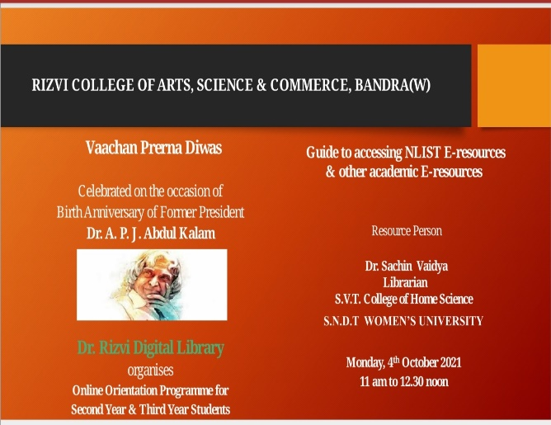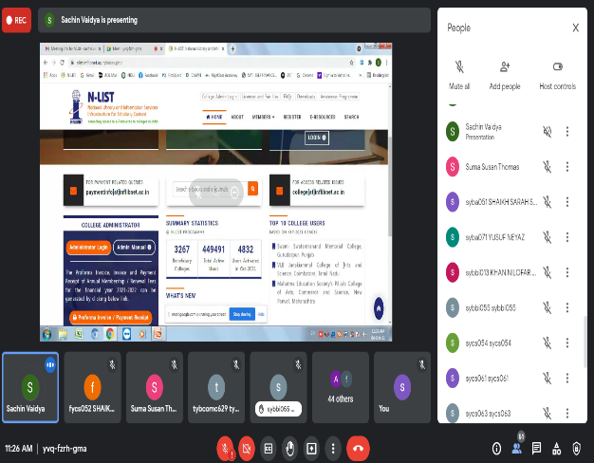

3) Library Orientation for Students
6th to 10th December, 2021 (294 students attended)
First year students were introduced to the library and its facilities. They were taught to access books through Web Opac and to access E-resources through library website www.librarydrdl.com
Offline session was conducted for students where they were informed about the library facilities. They were encouraged to and shown how to make use of our library e-resources through our library website. Various features of our website www.librarydrdl.com were explained to them.

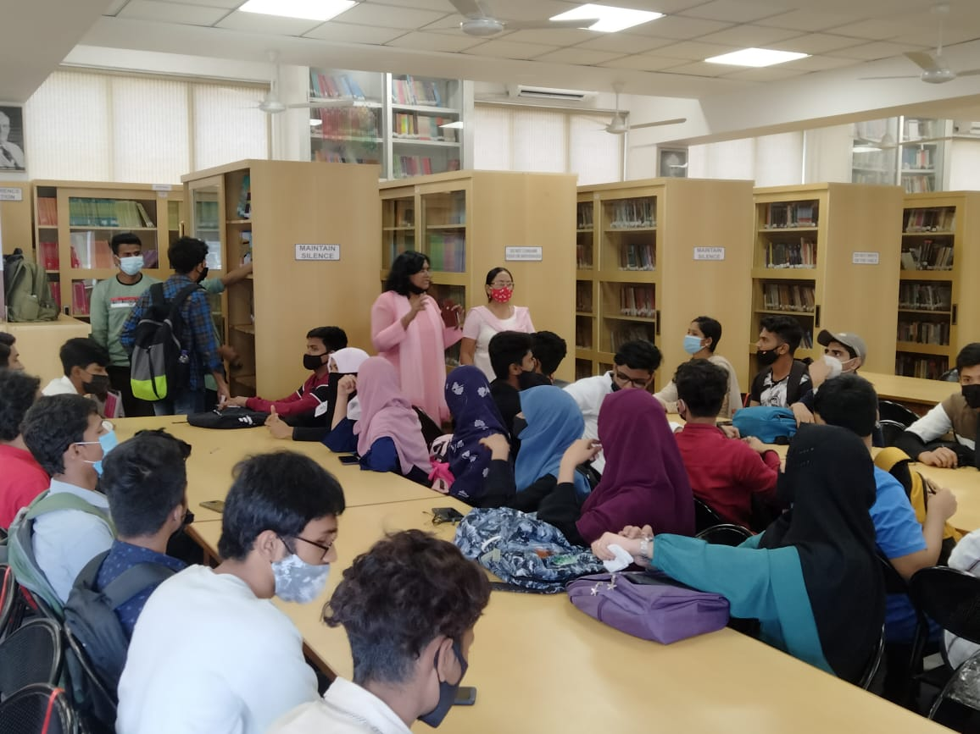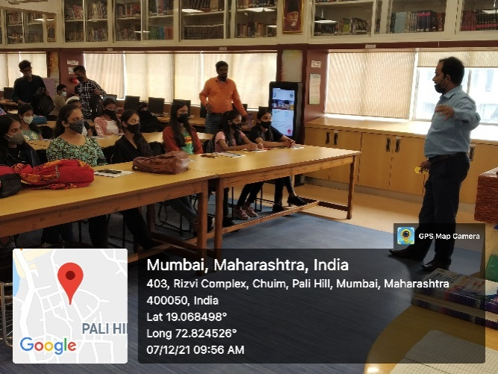

4) I Love my Library Initiative : Competition on Library Opinion Essays and Library Facts. 28th January, 2022
To promote library and library resources usage, a competition was organised for the students. Students had to write opinion essays on Library related topics to guage their knowledge on current state of reading culture among youth, future of print books, difference between google and books . They had to write their opinion on these topics and submit handwritten essays. Under Library facts, questions were asked to understand whether they know basic facts about the college library.Marks were given based on essay content and questions answered. Prize winners were given books as present .

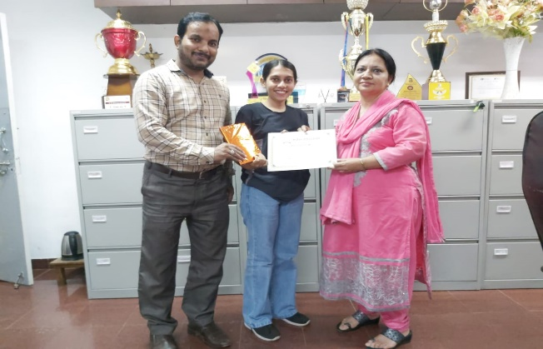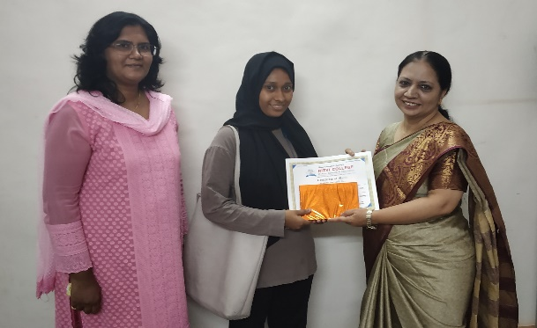

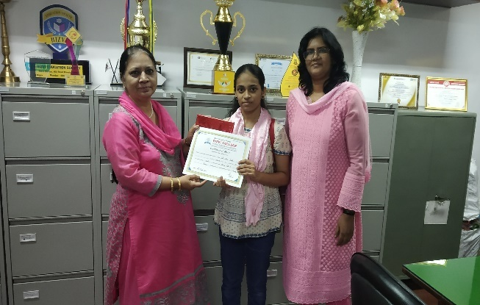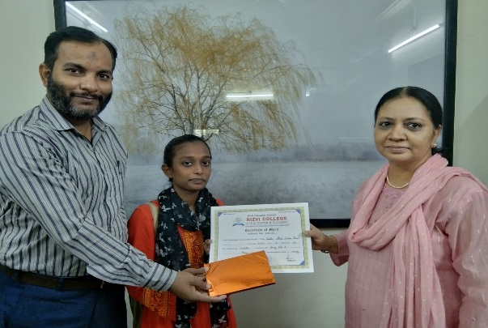

5) Literature Search and Review: the base of Research Process
2nd March 2022 (14 Teachers attended)
Dr.Rizvi Digital Library and Research Cell organised an Online lecture on Literature Search and Review: the base of research process, by Dr. Sushma Powdwal , Retd. University Librarian, SNDT Women’s University for our teachers on 2nd March 2022 .Literature search and review is the most important step of any research process, hence to add value to the research done by our teachers, this lecture was organised. Dr. Sushma Powdwal gave information on objectives of Literature review and steps to write a literature review. Steps to conduct Gap Analysis was also looked upon. Different Literature search tools, sources and resources which can be used to refine the search output were explained . Tips on searching skills like which terms, signs, Boolean operators to be used were shared by the resource person. Examples of different online resources available like e- journal databases, institutional repositories, thesis database, consortium were given to find the relevant information for research. The teachers gained added knowledge to sharpen their research focus.
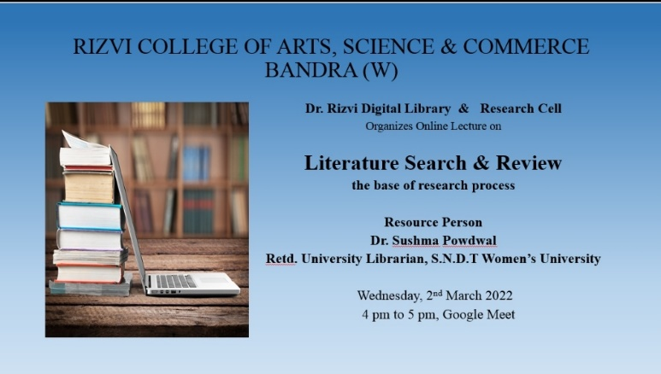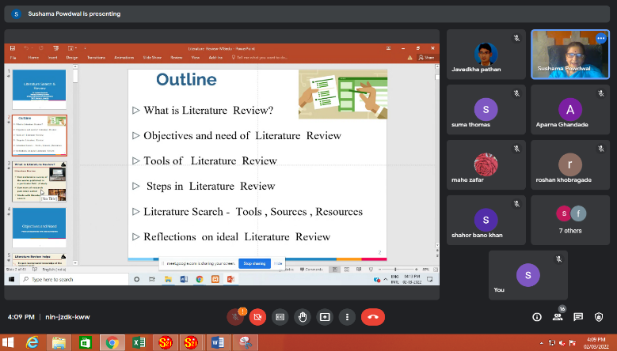
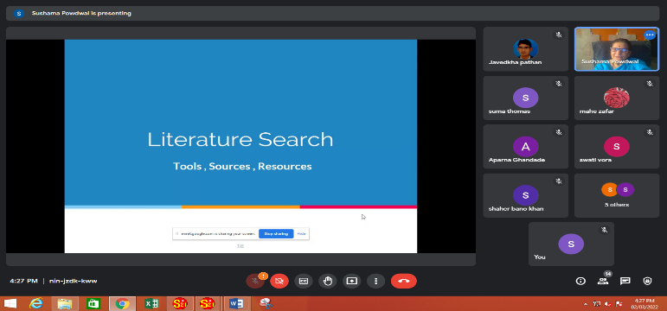

DEPT Physics
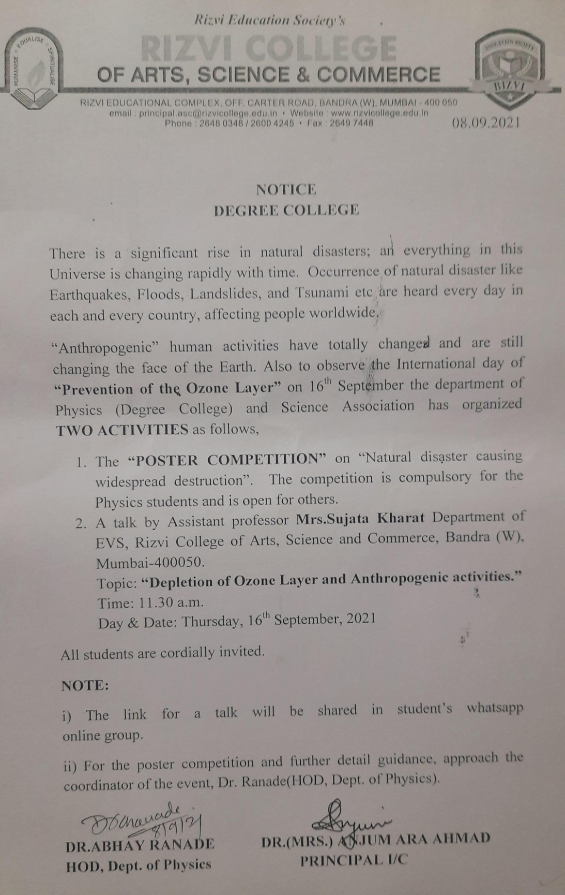
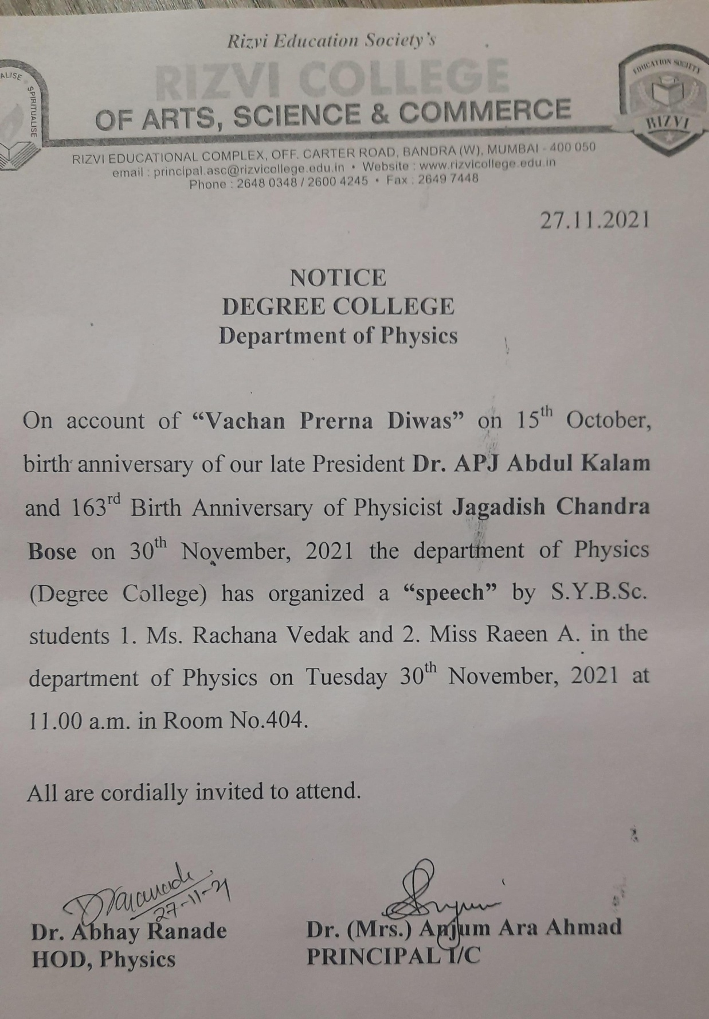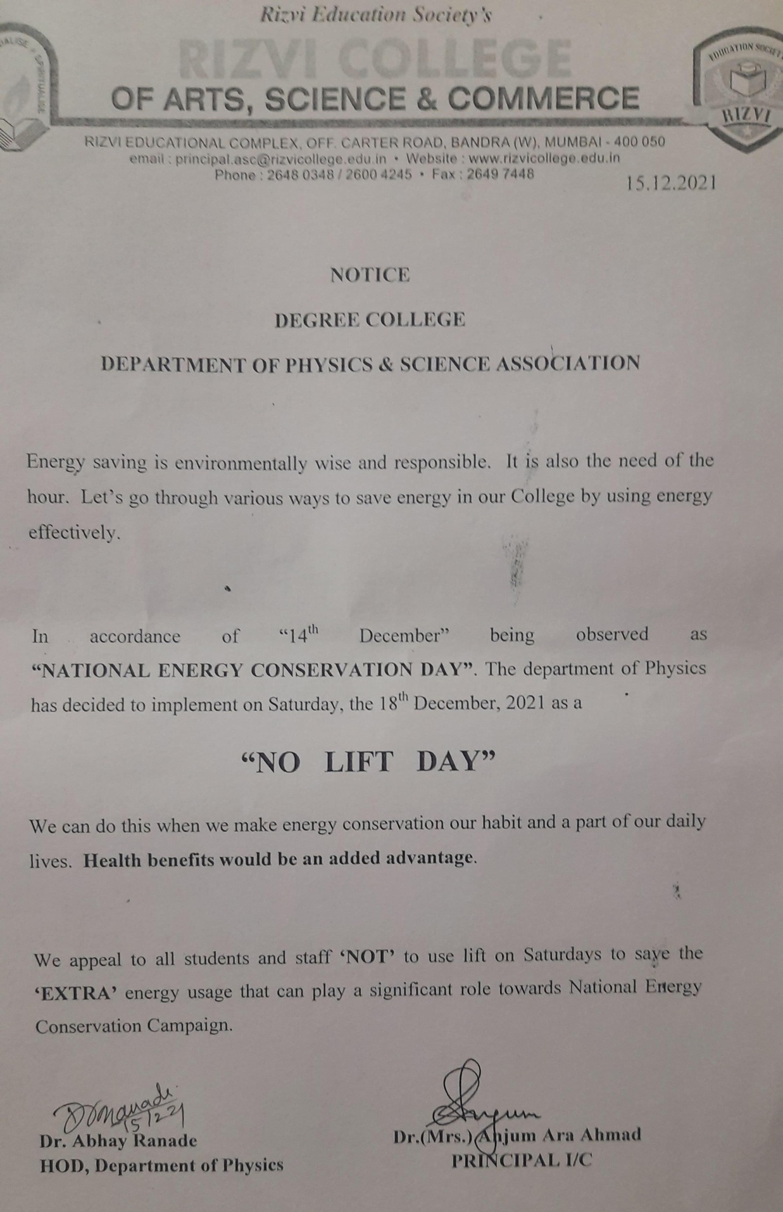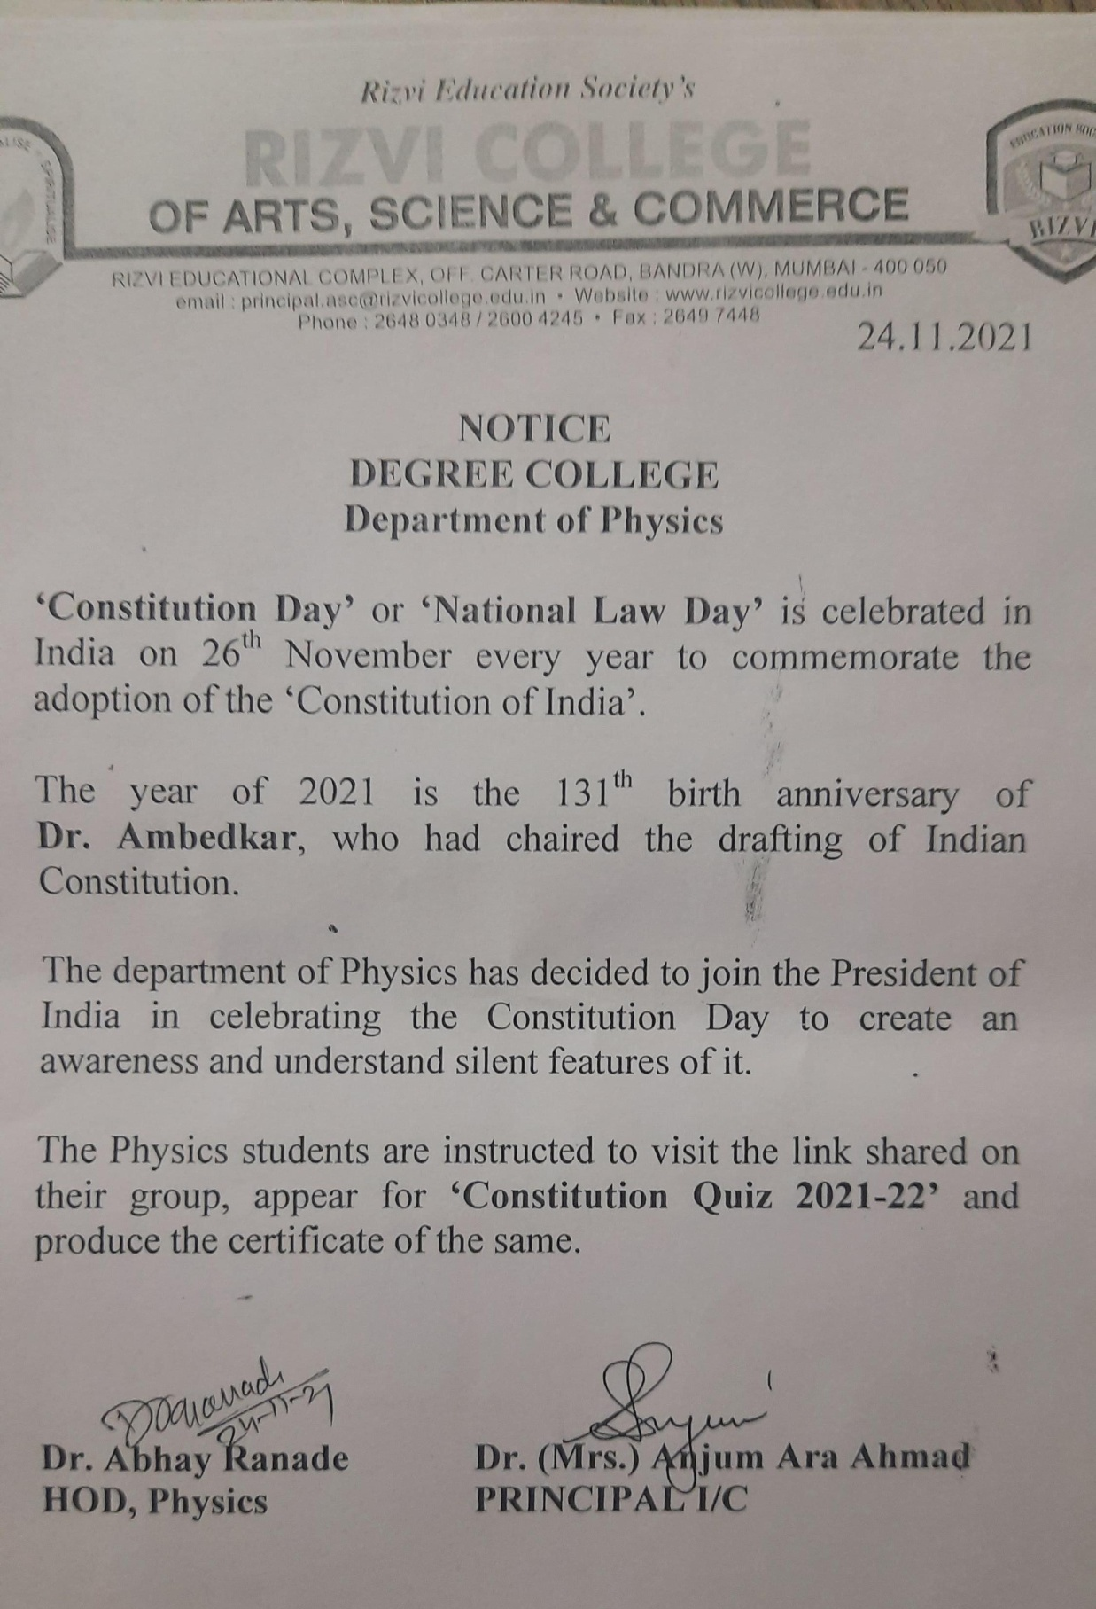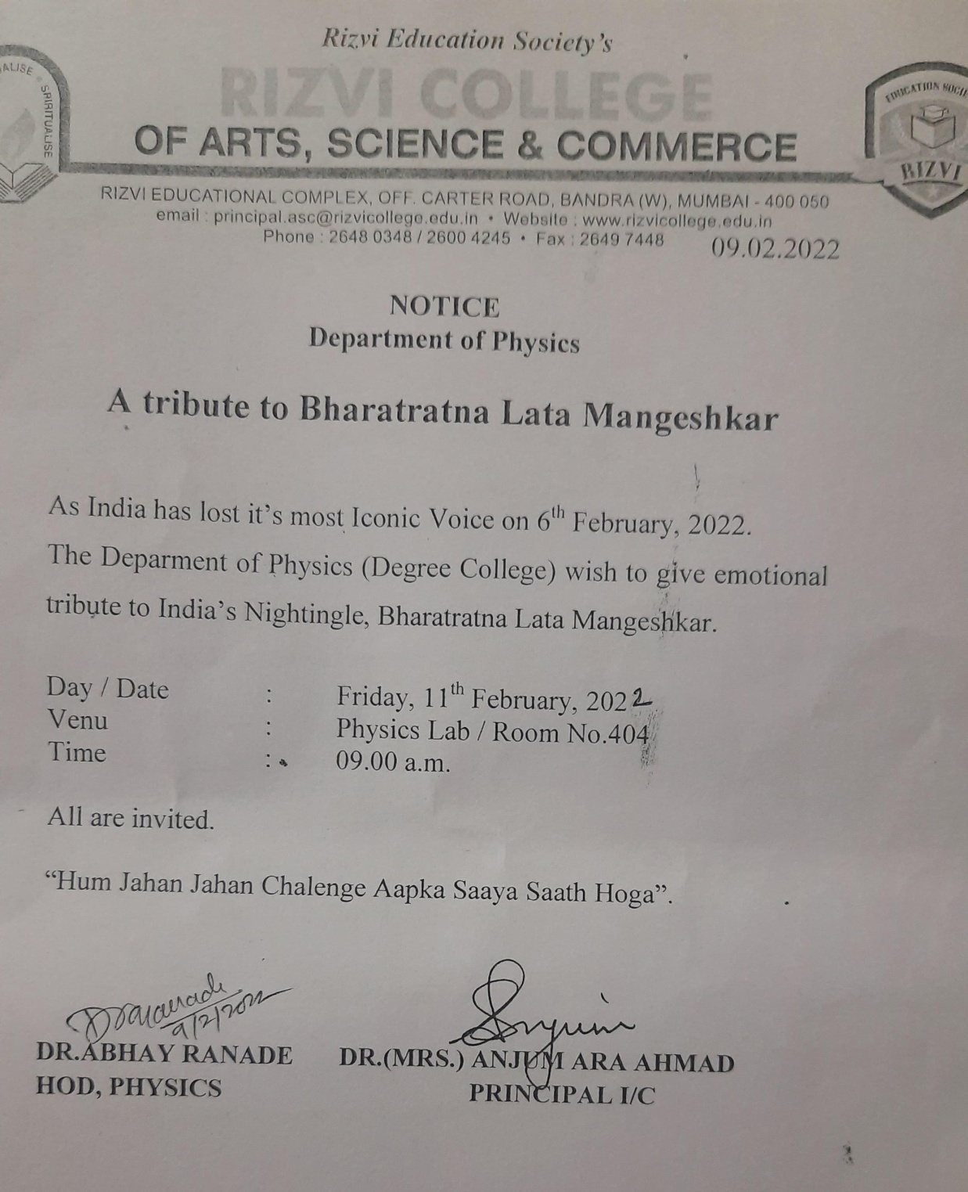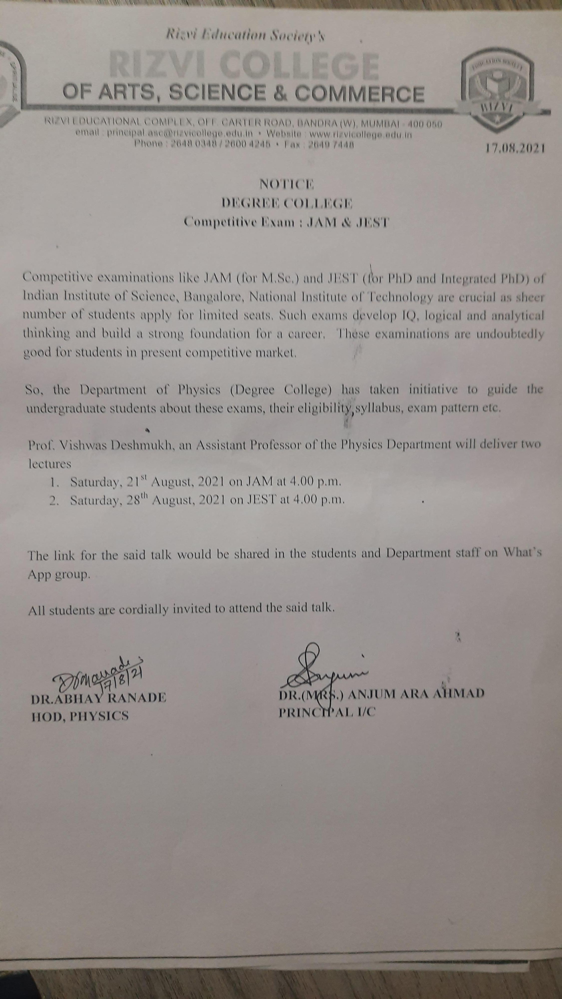

DEPT Sociology
Homage to Kamla Bhasin
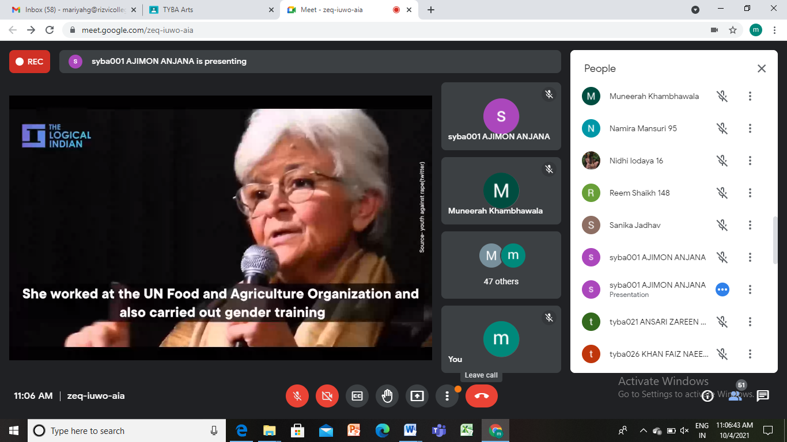

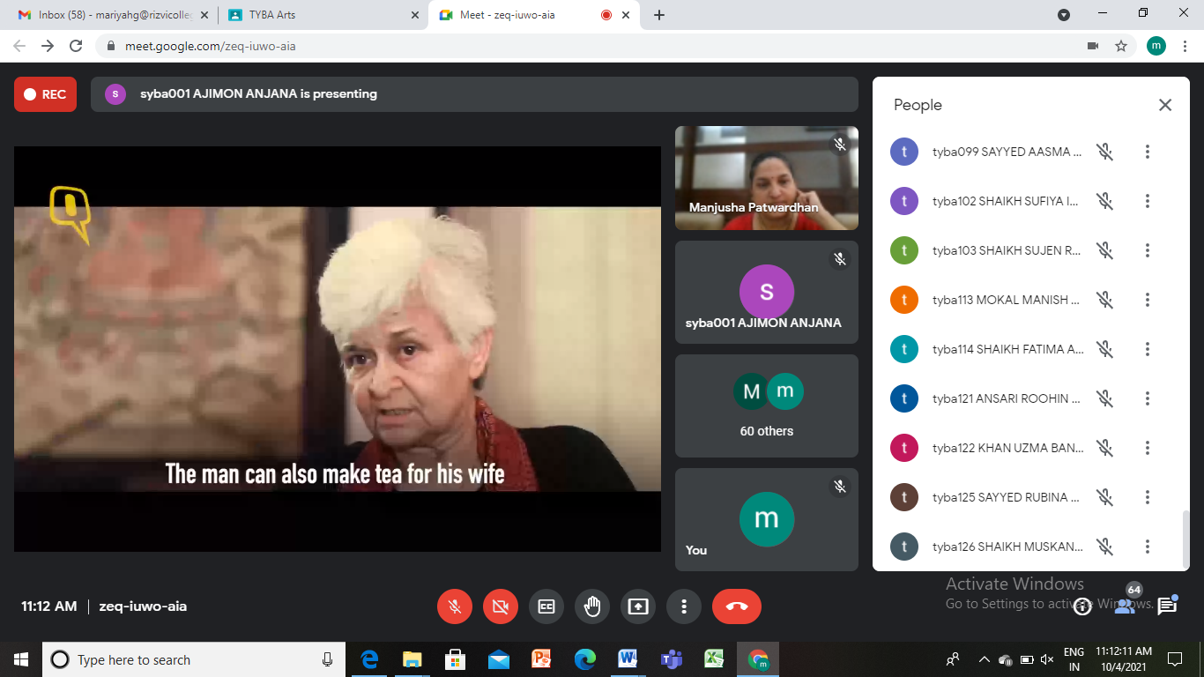

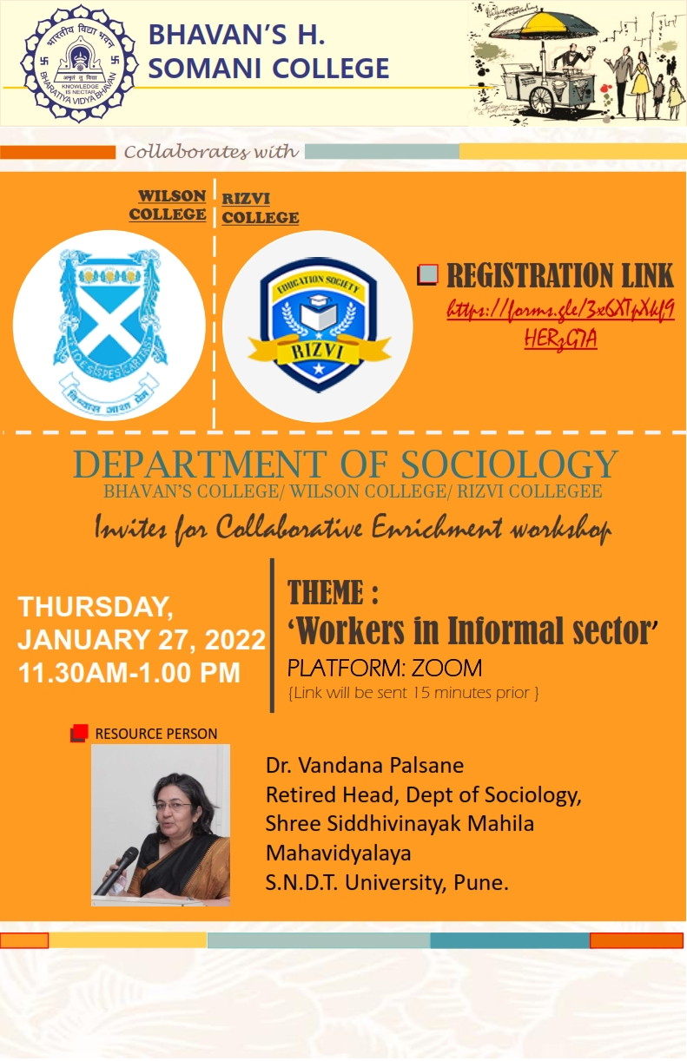
DEPT Law

- Guest Lecture on “UPSC/MPSC and Allied services.”
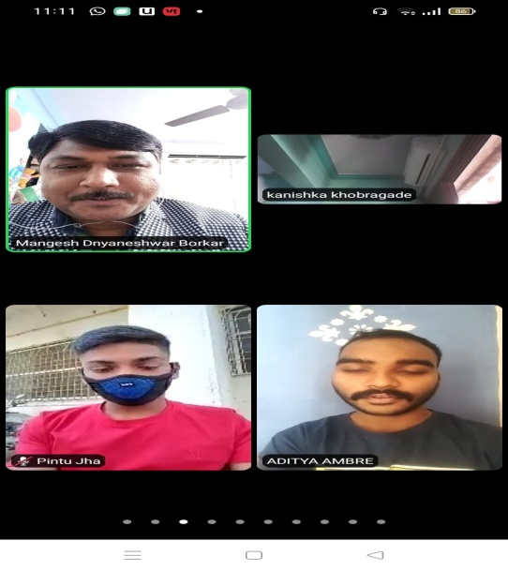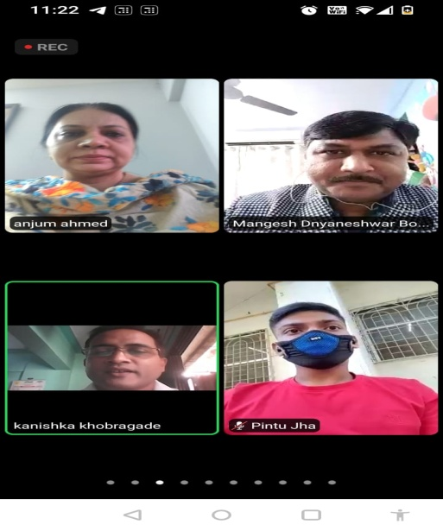

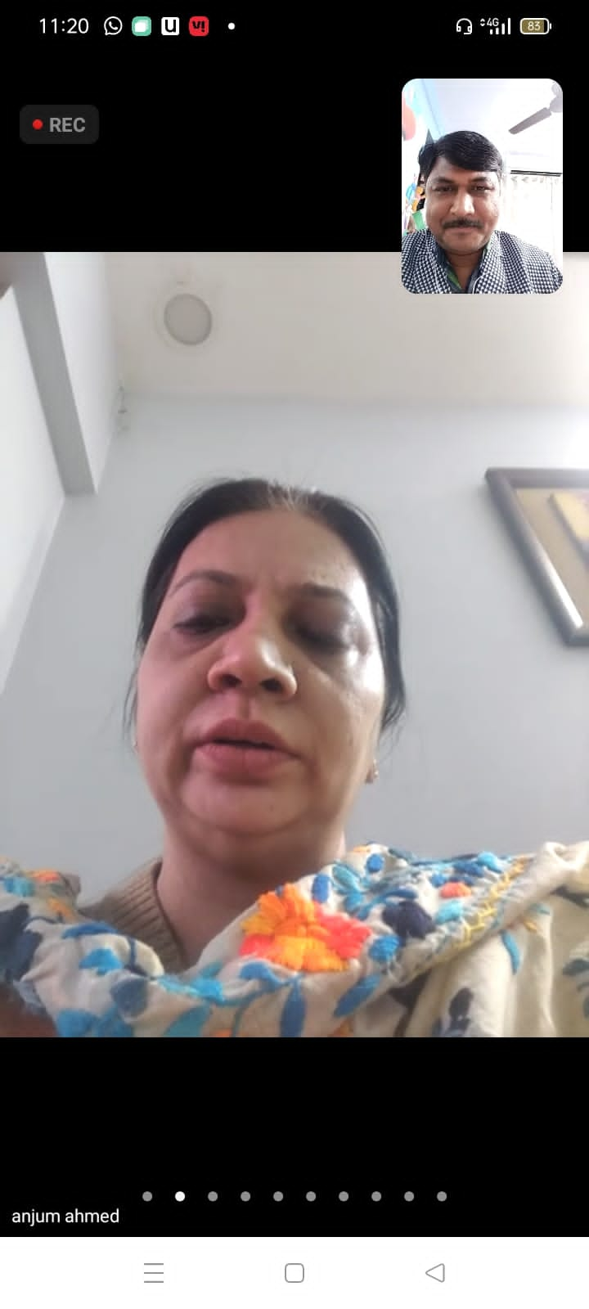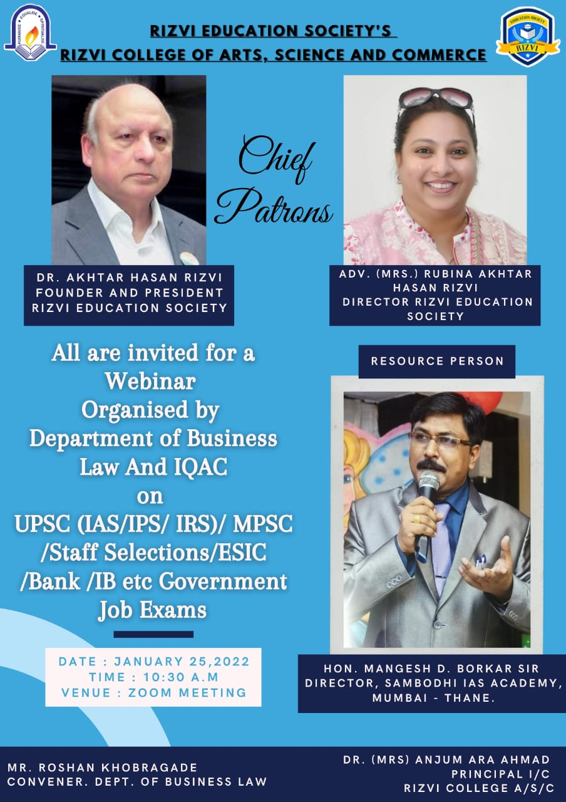

2. Guest lecture on “How to crack Government Exam in First attempt.”

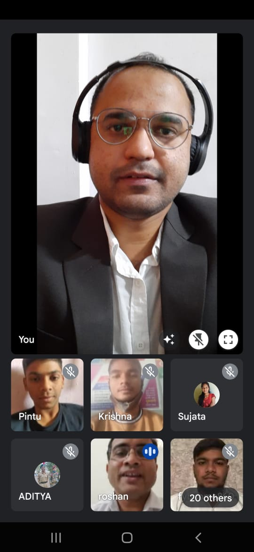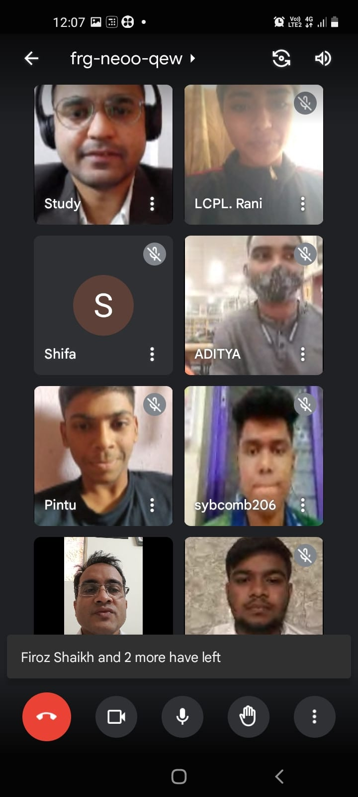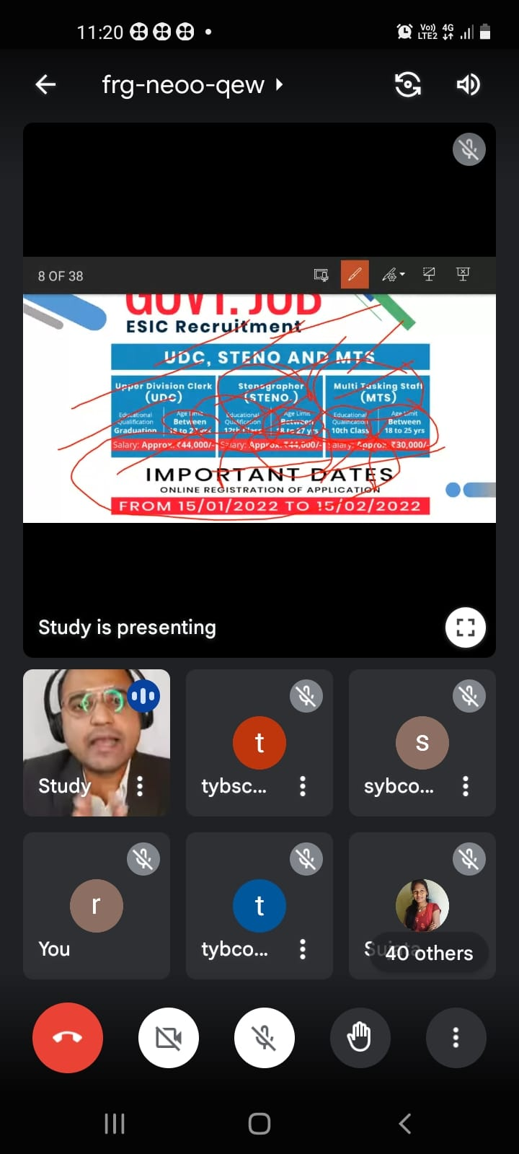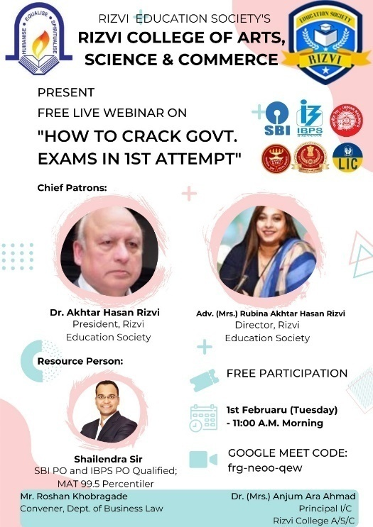

3. Workshop on Intellectual Property Law.

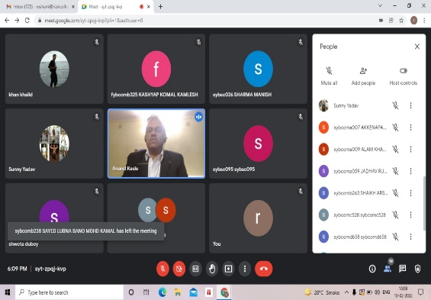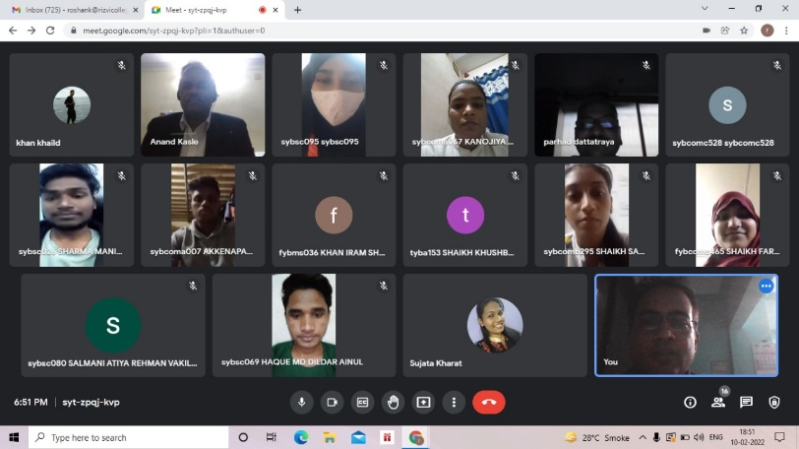

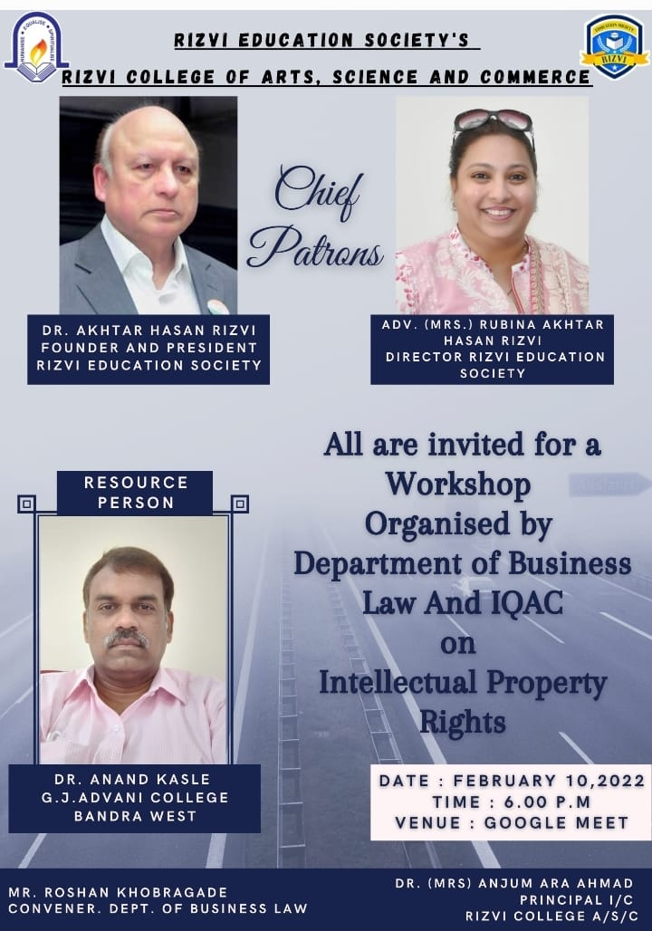

DEPT CS
IQAC and Dept. of CS & IT jointly organized a Workshop on ‘Geo Tagged Photograph’ on 18th December, 2021 at 11.00 am in CS/IT lab. Mr. Zari Haider Zaidi, Assistant Professor, (Dept. of CS/IT) was the resource person. He demonstrated the skill with live presentation and resolved all the queries effectively. 23 Teachers across the faculties actively participated in the same and learnt the skill of ‘Geo Tagged Photograph’.

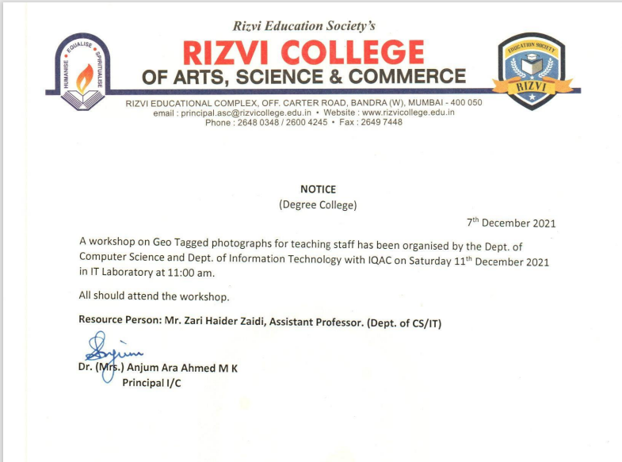
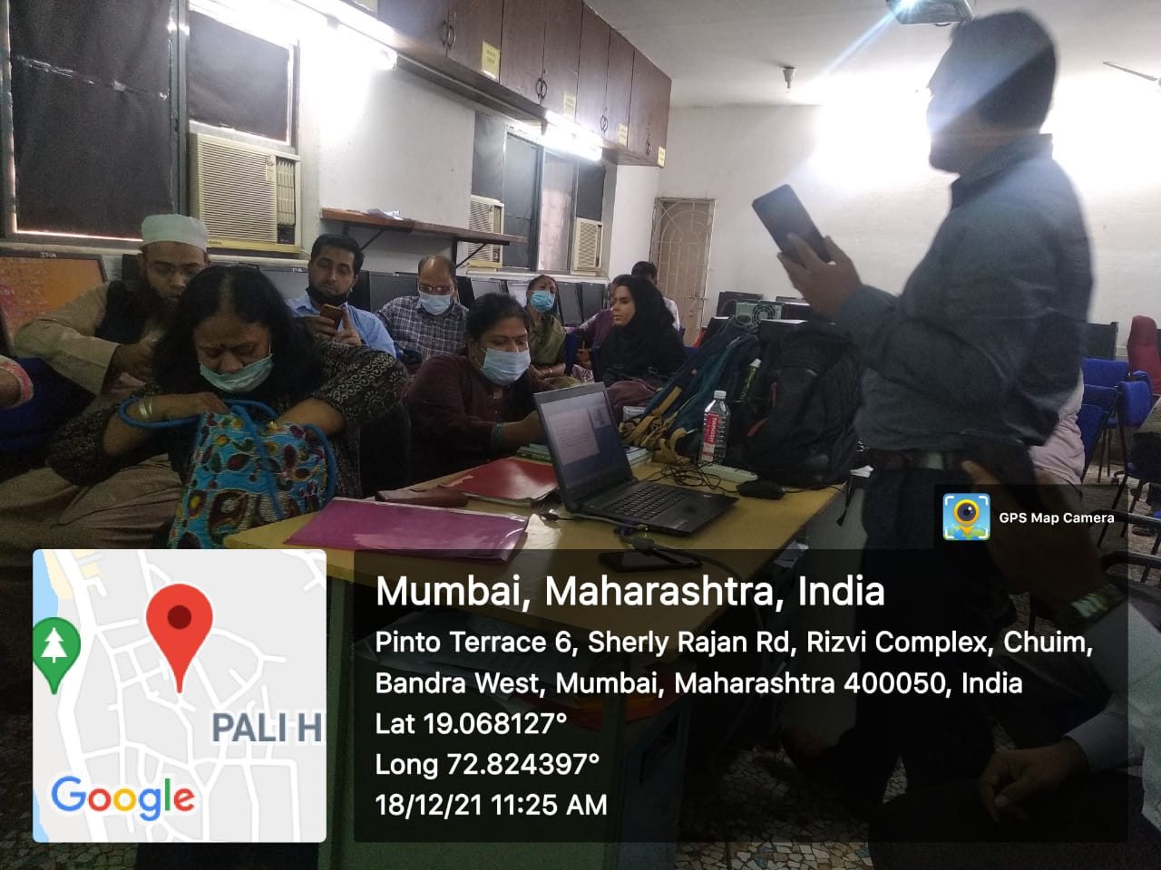

- A Webinar on “Emerging Technologies in Information Technology” was held by Information Technology and Computer Science departments on 8th September, 2021 in association with Edubridge learning Pvt. Ltd. for Third Year B.Sc. I.T. & B.Sc. C.S. students. The speakers Ms. Midhiya and Mr. Sidharth Sirohia introduced the audience to the latest developments and emerging technologies in the IT world. They informed the students how different frameworks like Django and Angular JS and languages such as Python and Java can be used together to build a sophisticated and highly dynamic websites. A total of 69 students attended this webinar

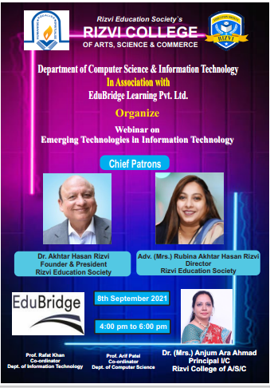

- A Certificate Course of 30 hours on “Cyber Security and Ethical Hacking Level 1” was conducted from 11th February, 2022 to 11th April, 2022 by IndiaTech Pvt. Ltd. A total of 64 students attended this course
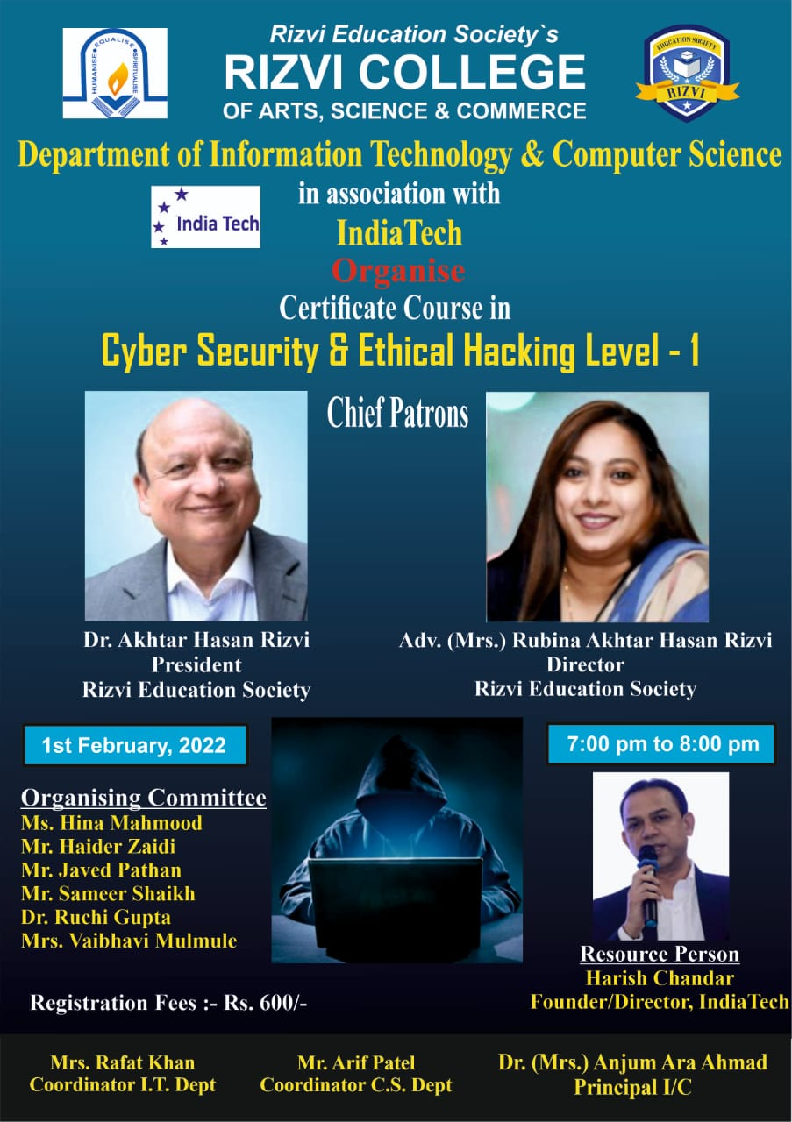

- A Certificate Course of 30 hours on “Cyber Security and Ethical Hacking Level 2” was conducted from 24th May, 2022 to 6th June, 2022 by IndiaTech Pvt. Ltd. A total of 34 students attended this course
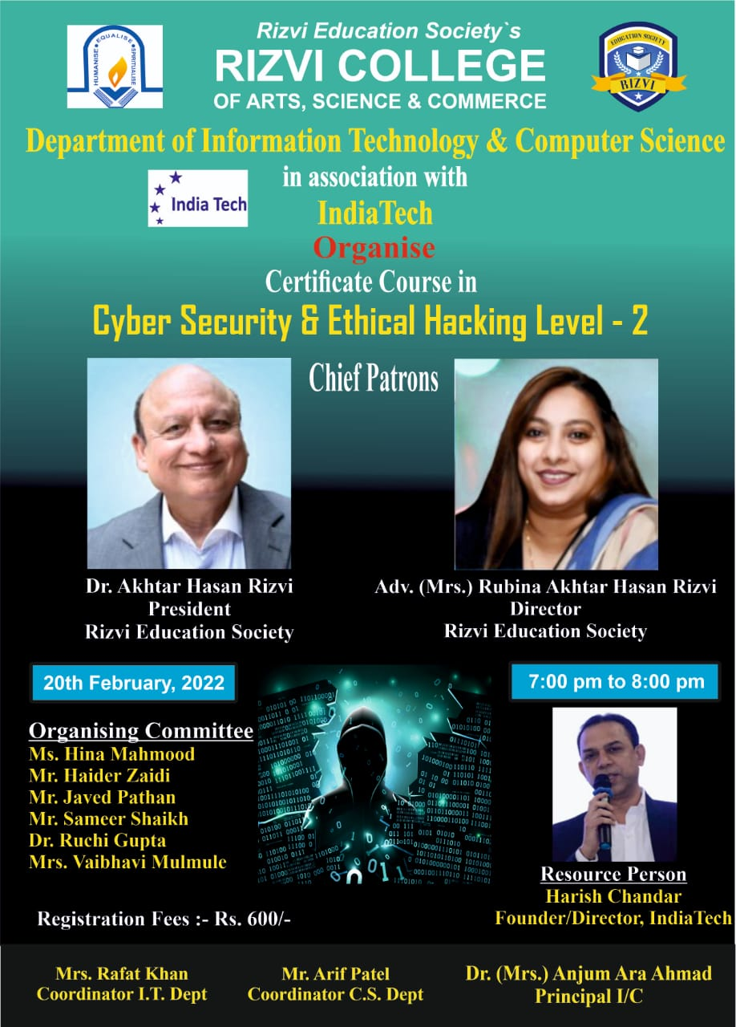

- A Certificate Course of 30 hours on “Data Analysis and Data Science Using Python” was conducted from 23rd February, 2022 to 18th May, 2022 by IndiaTech Pvt. Ltd. A total of 38 students attended this course
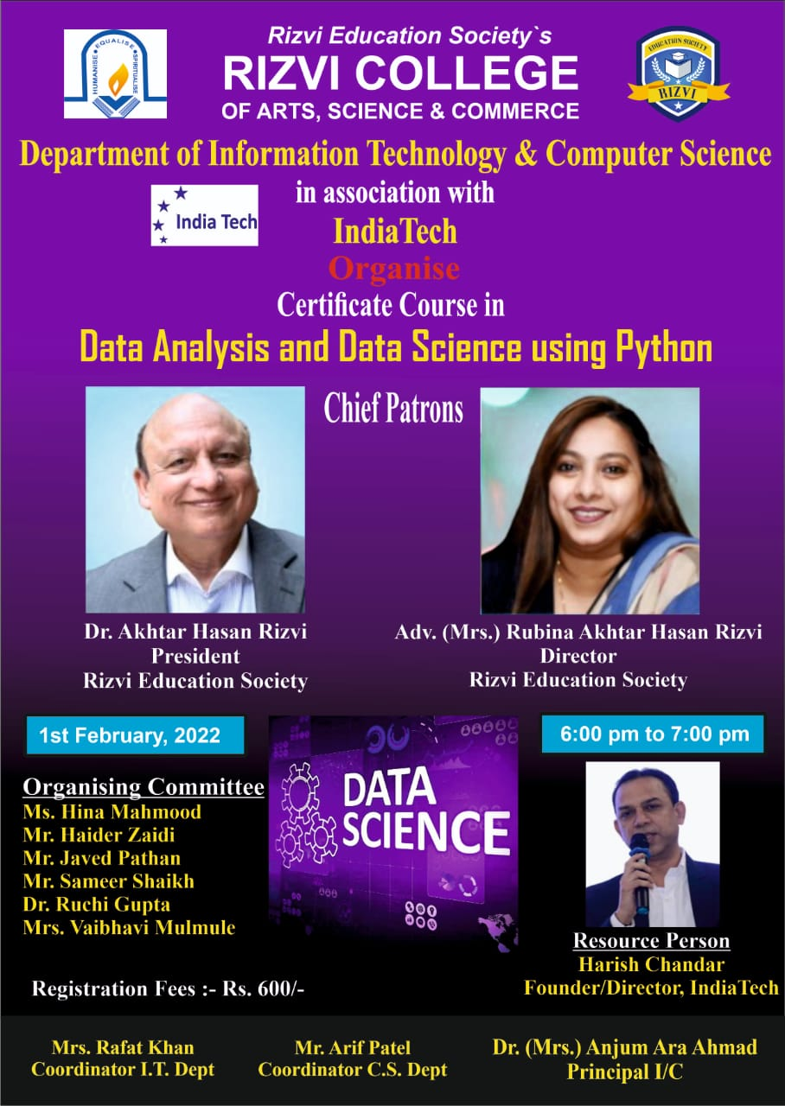

- Free Live Virtual training program on “Python for Data Science” was conducted by ExcelR under the MOU, for the duration of 42 hours, starting from 16th May 2022 (14 days, 3 hours daily ) from 11Am to 2Pm everyday, on weekdays. A total of 30 students registered for this course. Students were taught the concepts of Dictionaries, Data Handling, Numpy, Pandas, Data Wrangling, Data Visualization and Web Scraping

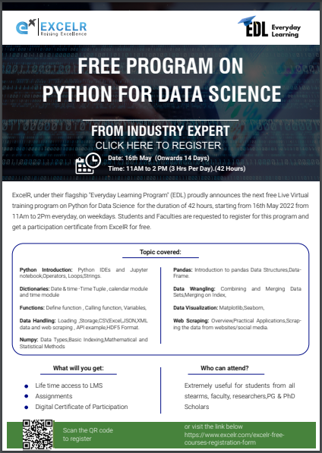

- Free Live Virtual training program on “Cloud Fundamentals” for the duration of 30 hours, starting from 20th June 2022 from 7PM to 9PM everyday, on weekdays. Topics covered were Cloud Basics, Azure, GCP and AWS. A total of 42 students registered for this course
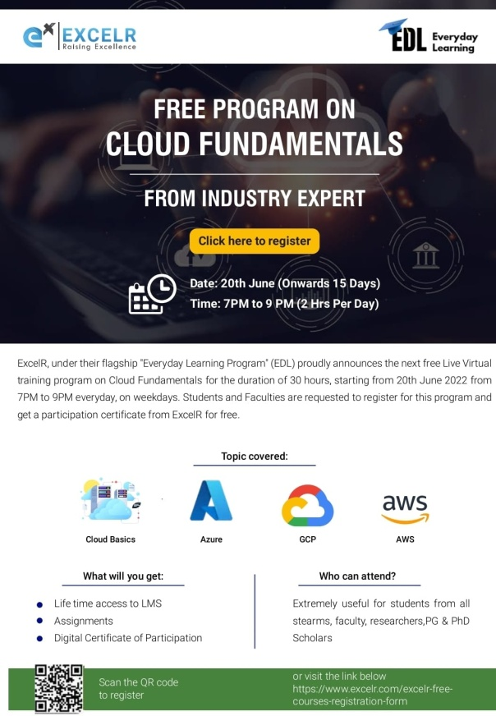

- Free Live Virtual training program on “Introduction to R programming and Tableau” for the duration of 30 hours, starting from 11th July 2022 from 7PM to 9PM every day, on weekdays. A total of 8 students registered for this course. Students were taught Data Types and data structures in R, Data Visualization, Data Connections, Organizing Data, Fields and Charts and Sharing Insights

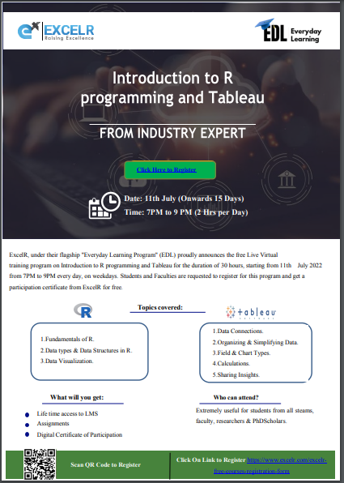

DEPT English
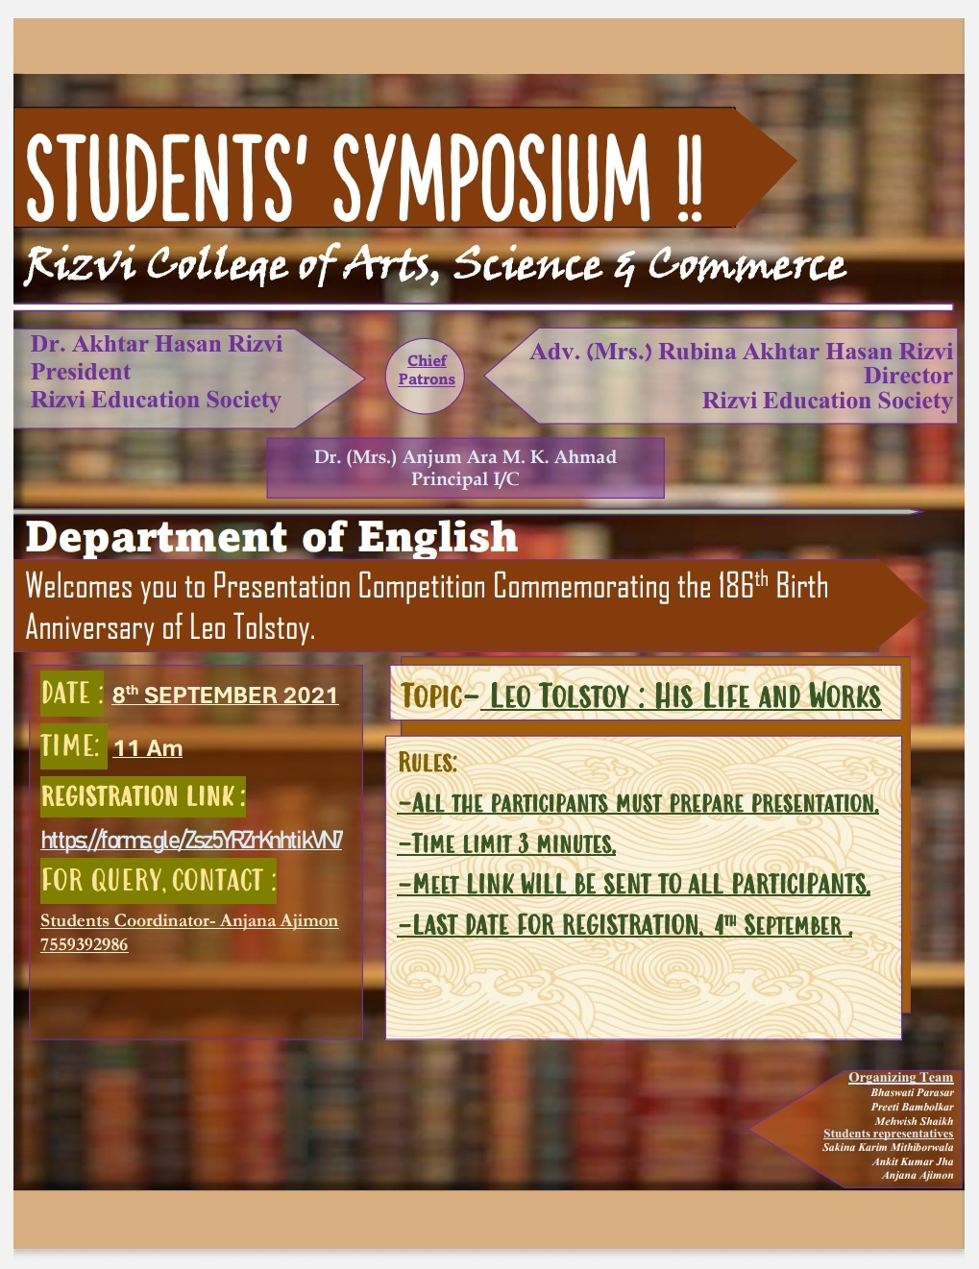

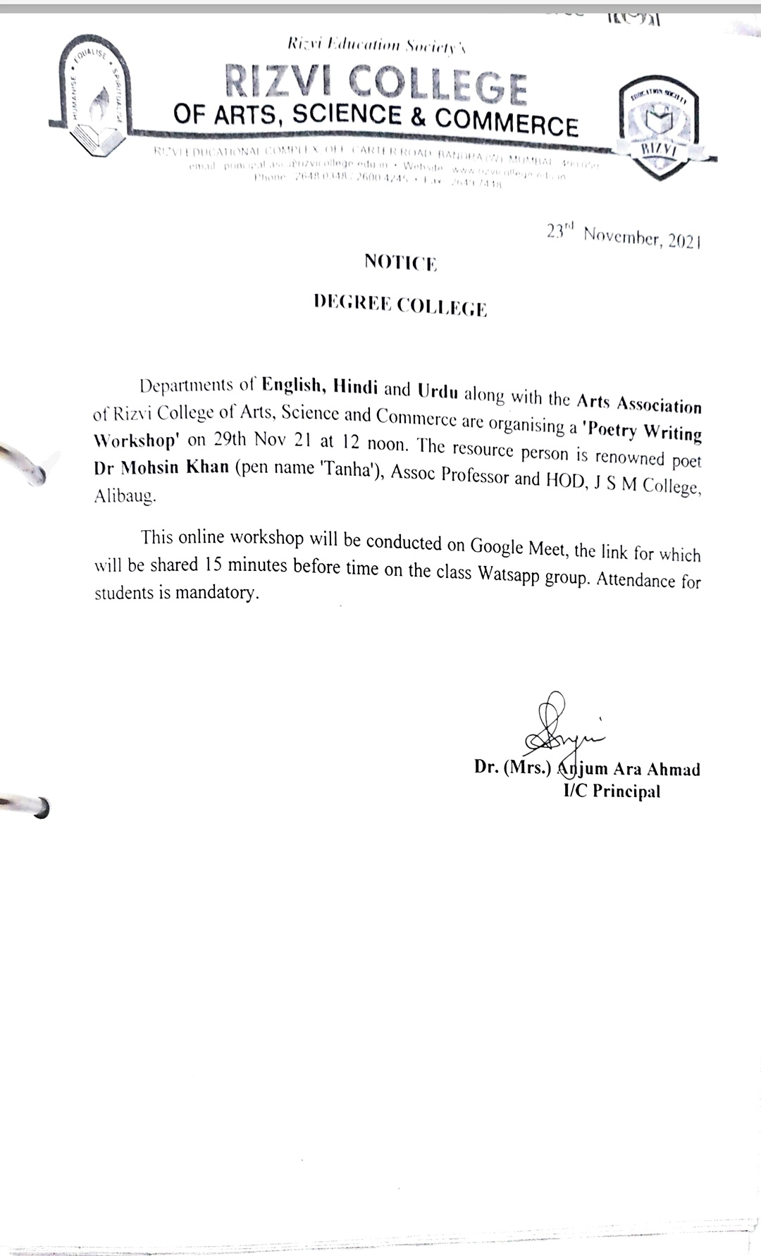

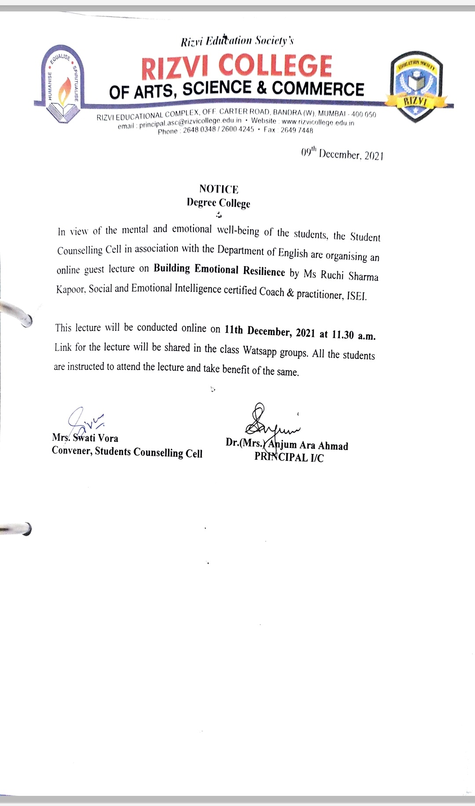
DEPT IT
IQAC and Dept. of CS & IT jointly organized a Workshop on ‘Geo Tagged Photograph’ on 18th December, 2021 at 11.00 am in CS/IT lab. Mr. Zari Haider Zaidi, Assistant Professor, (Dept. of CS/IT) was the resource person. He demonstrated the skill with live presentation and resolved all the queries effectively. 23 Teachers across the faculties actively participated in the same and learnt the skill of ‘Geo Tagged Photograph’.

- A Webinar on “Emerging Technologies in Information Technology” was held by Information Technology and Computer Science departments on 8th September, 2021 in association with Edubridge learning Pvt. Ltd. for Third Year B.Sc. I.T. & B.Sc. C.S. students. The speakers Ms. Midhiya and Mr. Sidharth Sirohia introduced the audience to the latest developments and emerging technologies in the IT world. They informed the students how different frameworks like Django and Angular JS and languages such as Python and Java can be used together to build a sophisticated and highly dynamic websites. A total of 69 students attended this webinar

- A Certificate Course of 30 hours on “Cyber Security and Ethical Hacking Level 1” was conducted from 11th February, 2022 to 11th April, 2022 by IndiaTech Pvt. Ltd. A total of 64 students attended this course

- A Certificate Course of 30 hours on “Cyber Security and Ethical Hacking Level 2” was conducted from 24th May, 2022 to 6th June, 2022 by IndiaTech Pvt. Ltd. A total of 34 students attended this course

- A Certificate Course of 30 hours on “Data Analysis and Data Science Using Python” was conducted from 23rd February, 2022 to 18th May, 2022 by IndiaTech Pvt. Ltd. A total of 38 students attended this course

- Free Live Virtual training program on “Python for Data Science” was conducted by ExcelR under the MOU, for the duration of 42 hours, starting from 16th May 2022 (14 days, 3 hours daily ) from 11Am to 2Pm everyday, on weekdays. A total of 30 students registered for this course. Students were taught the concepts of Dictionaries, Data Handling, Numpy, Pandas, Data Wrangling, Data Visualization and Web Scraping

- Free Live Virtual training program on “Cloud Fundamentals” for the duration of 30 hours, starting from 20th June 2022 from 7PM to 9PM everyday, on weekdays. Topics covered were Cloud Basics, Azure, GCP and AWS. A total of 42 students registered for this course

- Free Live Virtual training program on “Introduction to R programming and Tableau” for the duration of 30 hours, starting from 11th July 2022 from 7PM to 9PM every day, on weekdays. A total of 8 students registered for this course. Students were taught Data Types and data structures in R, Data Visualization, Data Connections, Organizing Data, Fields and Charts and Sharing Insights

- Online course on “C and C++” was conducted in association with Spoken Tutorial during July – December 2021 session. A total of 8 students enrolled in the course
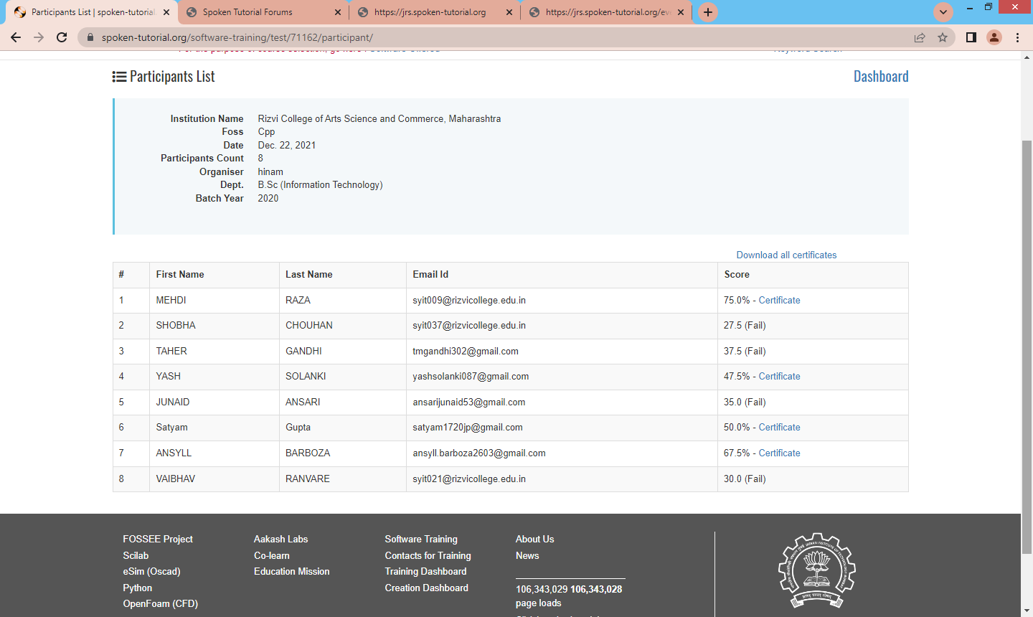

DEPT Zoology
Workshop of Intestinal health and Pro-biotics

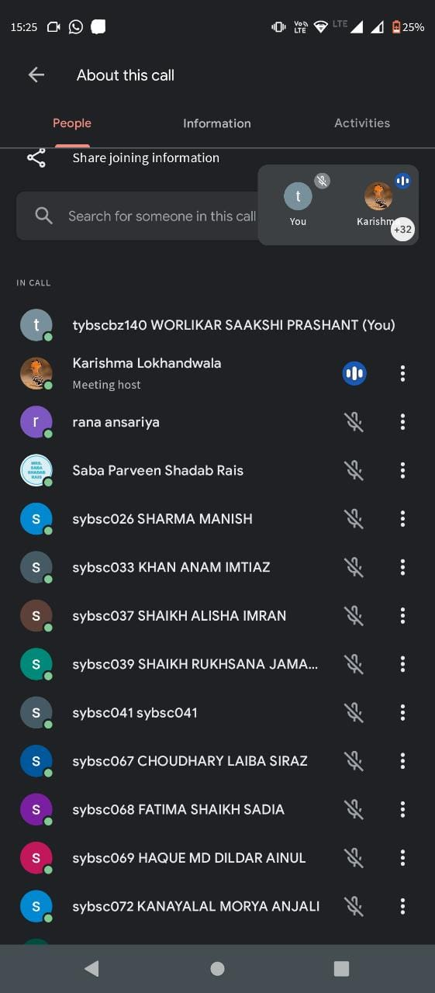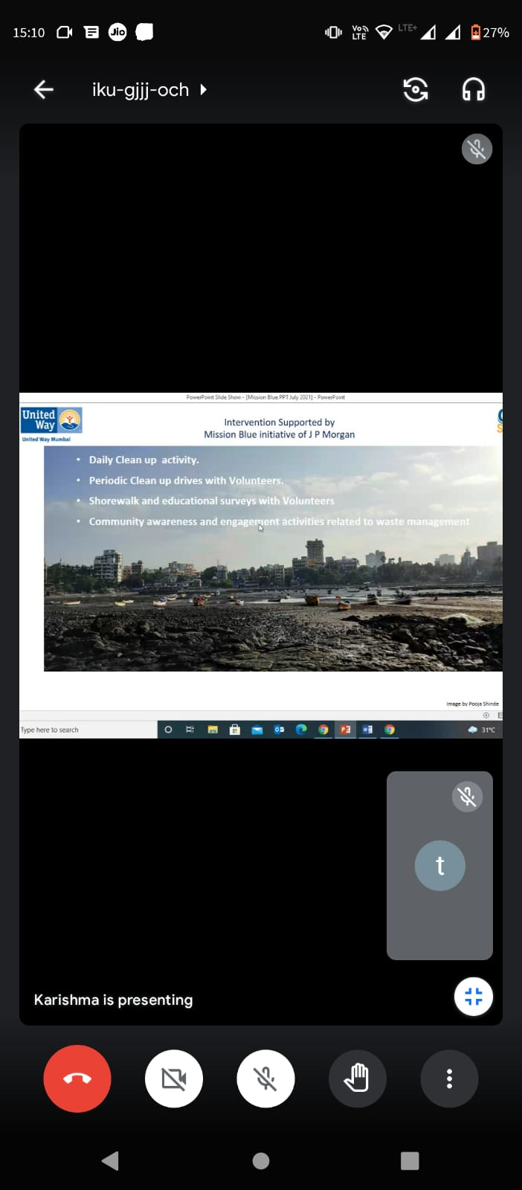

Webinar on marine pollution
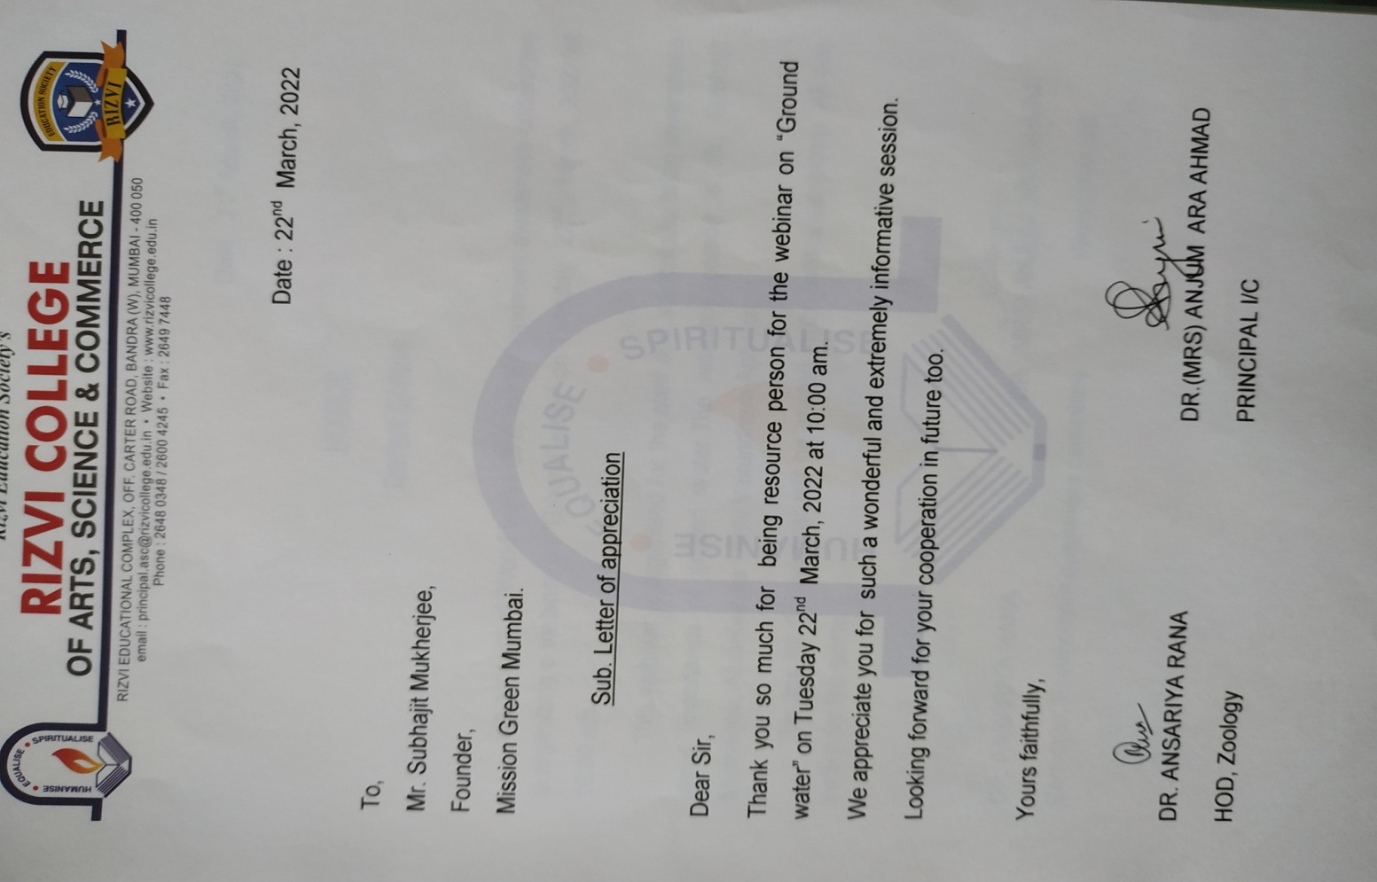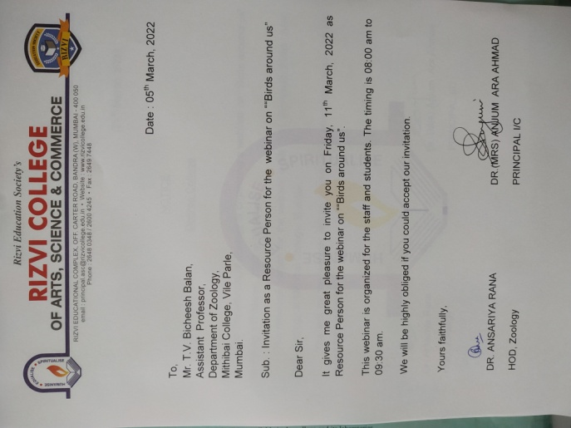

Webinar on birds around us

,. 