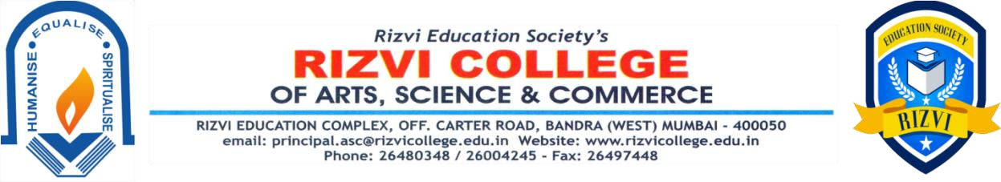

Action Taken Report on Curriculum Feedback_2021 - 22

During Academic Year 2021 - 22, feedback on the curriculum was obtained online from the teachers, students, alumni and employers. A Google link of the questionnaire containing the relevant questions regarding the curriculum was e-mailed to the teachers, students, alumni and employers and the responses were analysed accordingly.

The Feedback Analysis Report along with the suggestions for a better curriculum designing is sent to the University for the Effective Implementation of the same in the revision of the syllabus of a particular course.

