DEPT. BAF
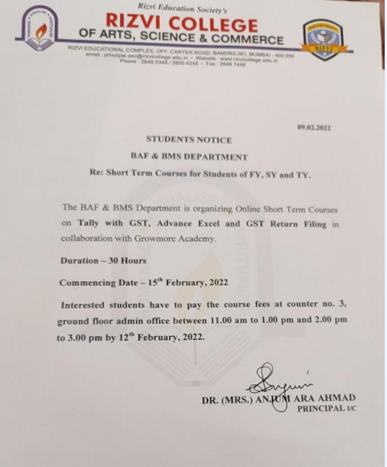
DEPT BAMMC
DEPT. BBI
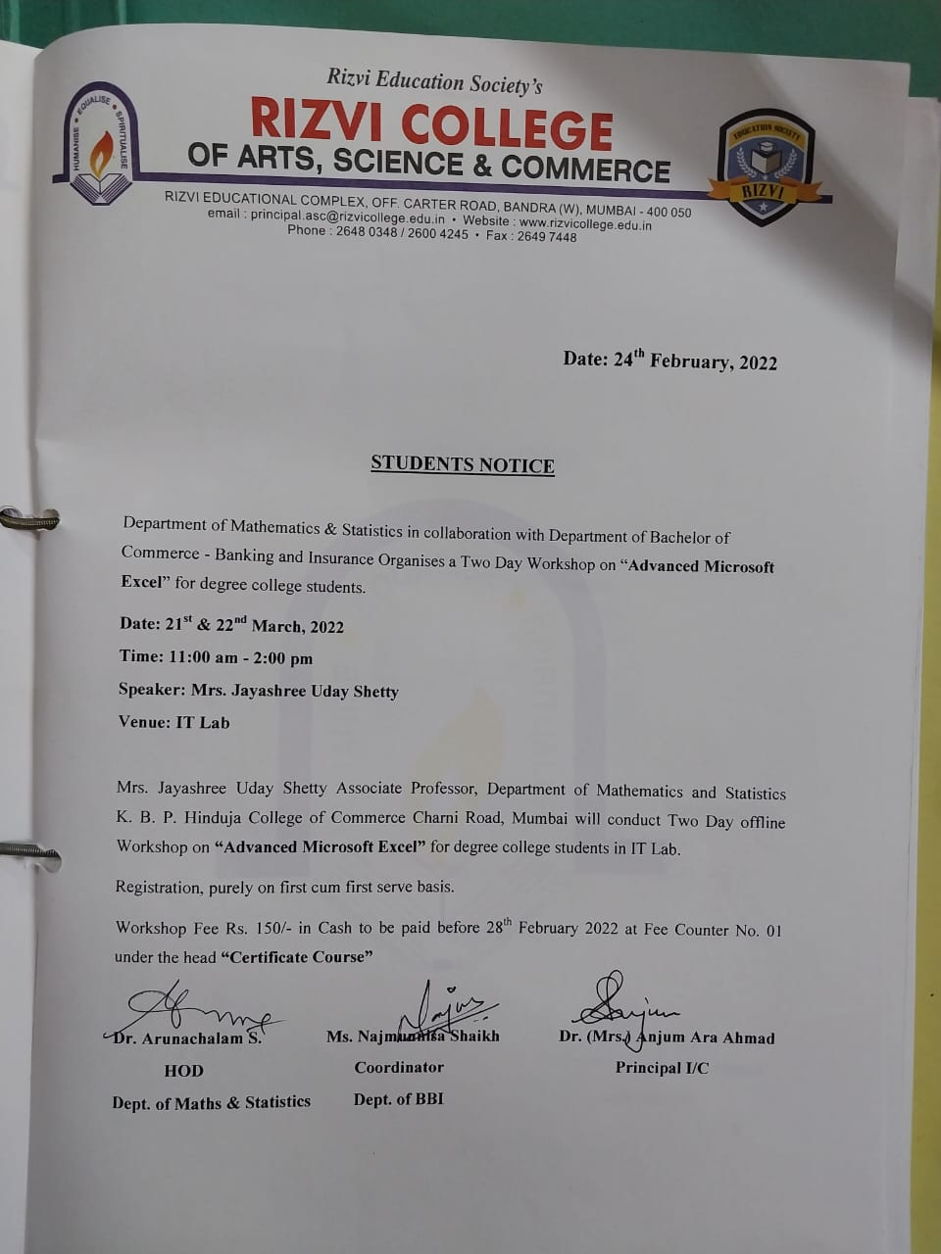
DEPT.BMS
DEPT BOTANY

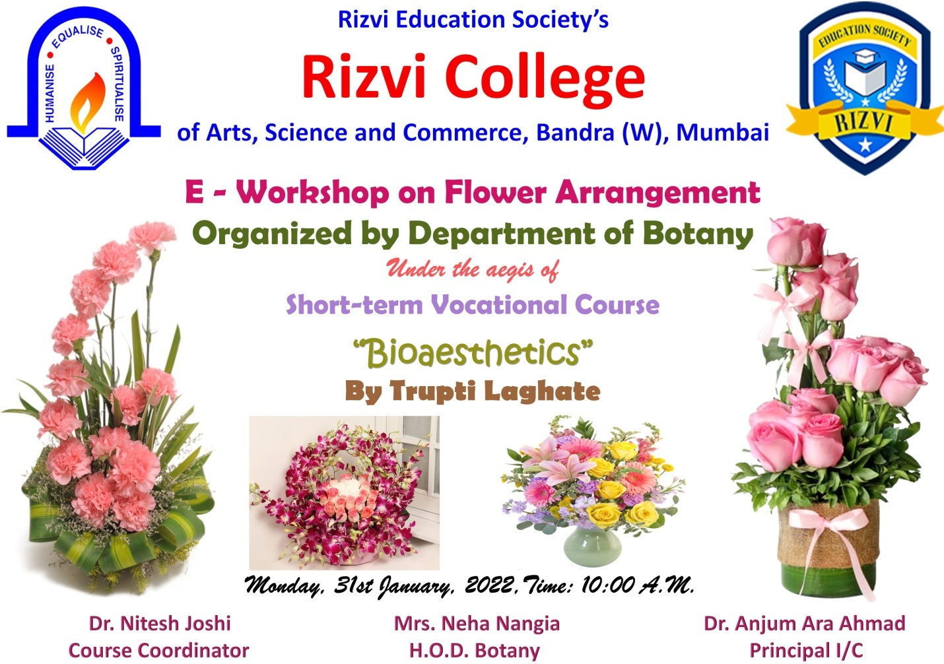

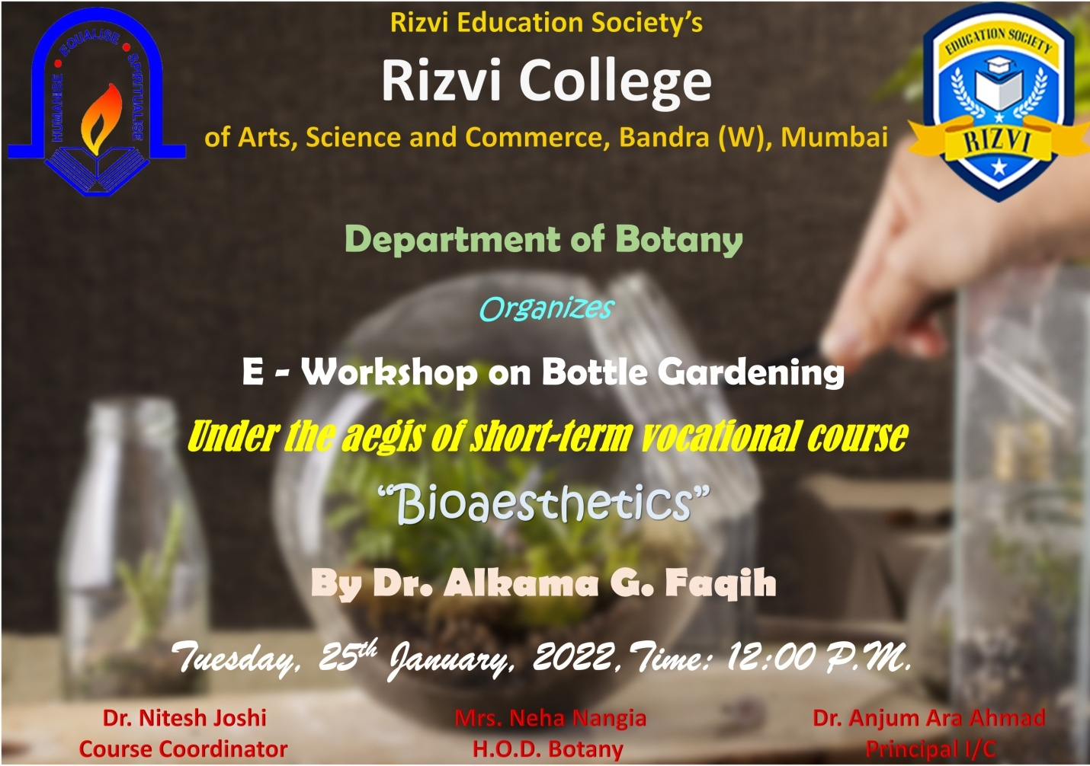
DEPT Sociology
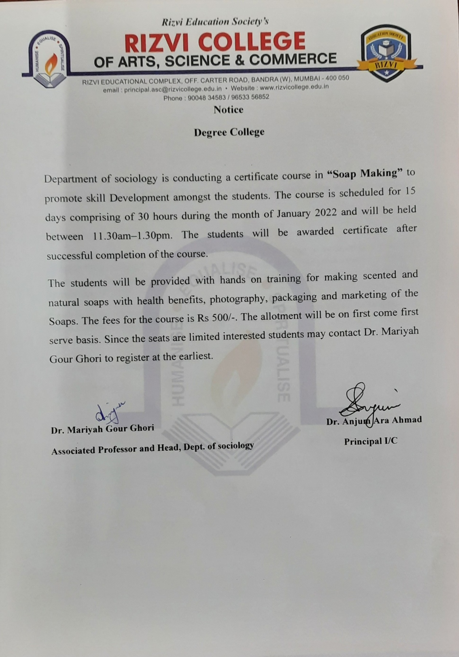
DEPT CS
A Certificate Course of 30 hours on “Cyber Security and Ethical Hacking Level 1” was conducted from 11th February, 2022 to 11th April, 2022 by IndiaTech Pvt. Ltd. A total of 64 students attended this course

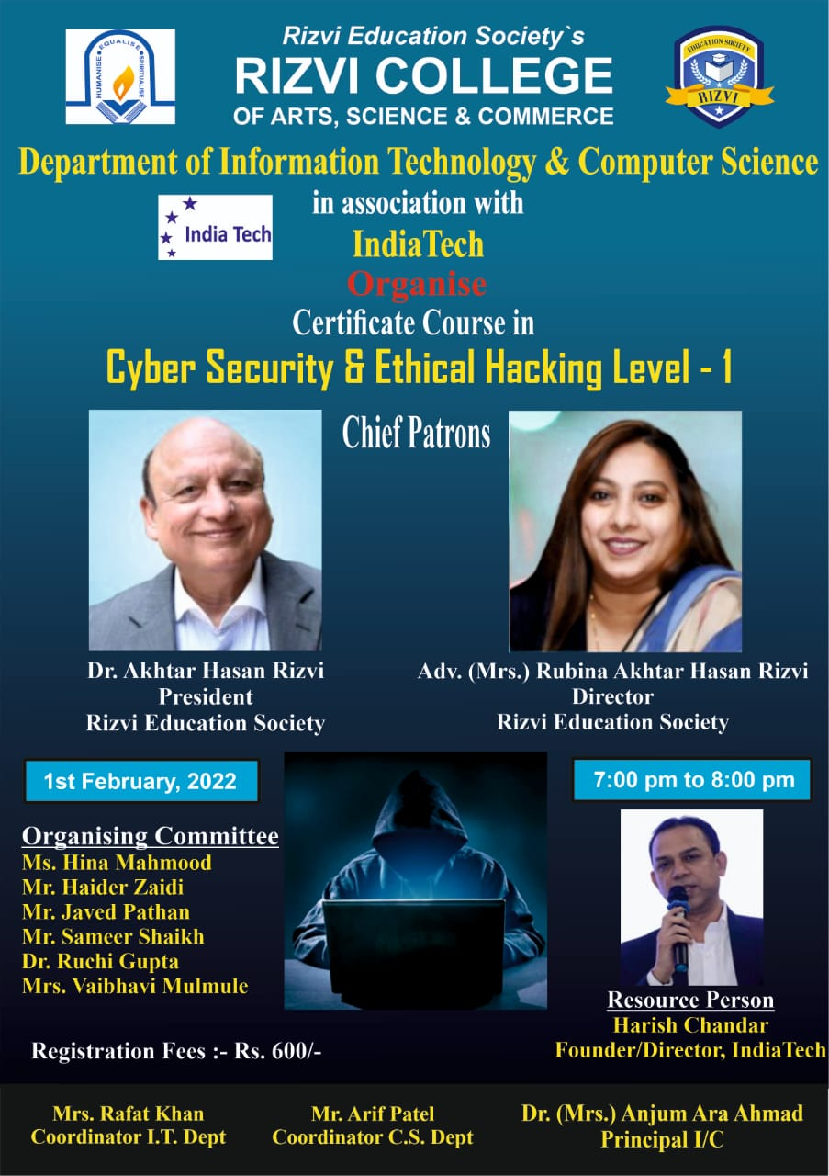

- A Certificate Course of 30 hours on “Cyber Security and Ethical Hacking Level 2” was conducted from 24th May, 2022 to 6th June, 2022 by IndiaTech Pvt. Ltd. A total of 34 students attended this course
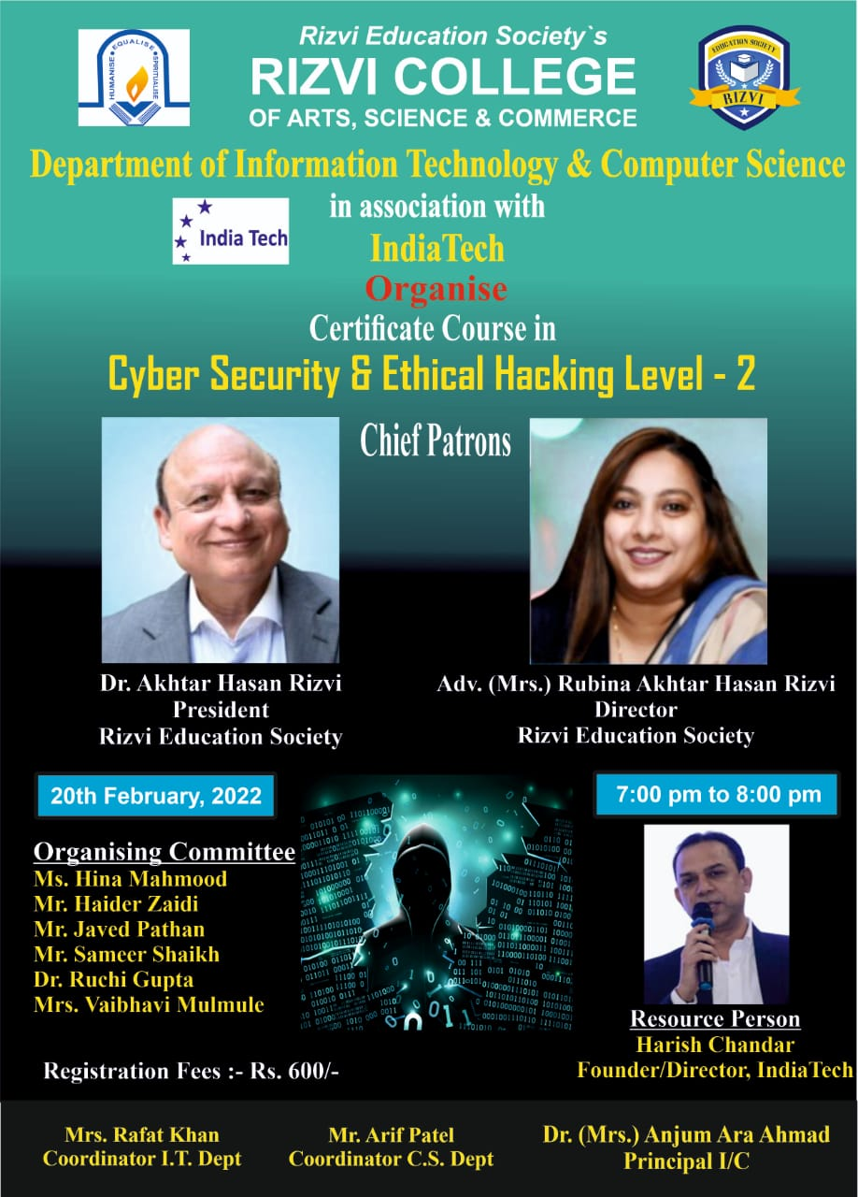

- A Certificate Course of 30 hours on “Data Analysis and Data Science Using Python” was conducted from 23rd February, 2022 to 18th May, 2022 by IndiaTech Pvt. Ltd. A total of 38 students attended this course
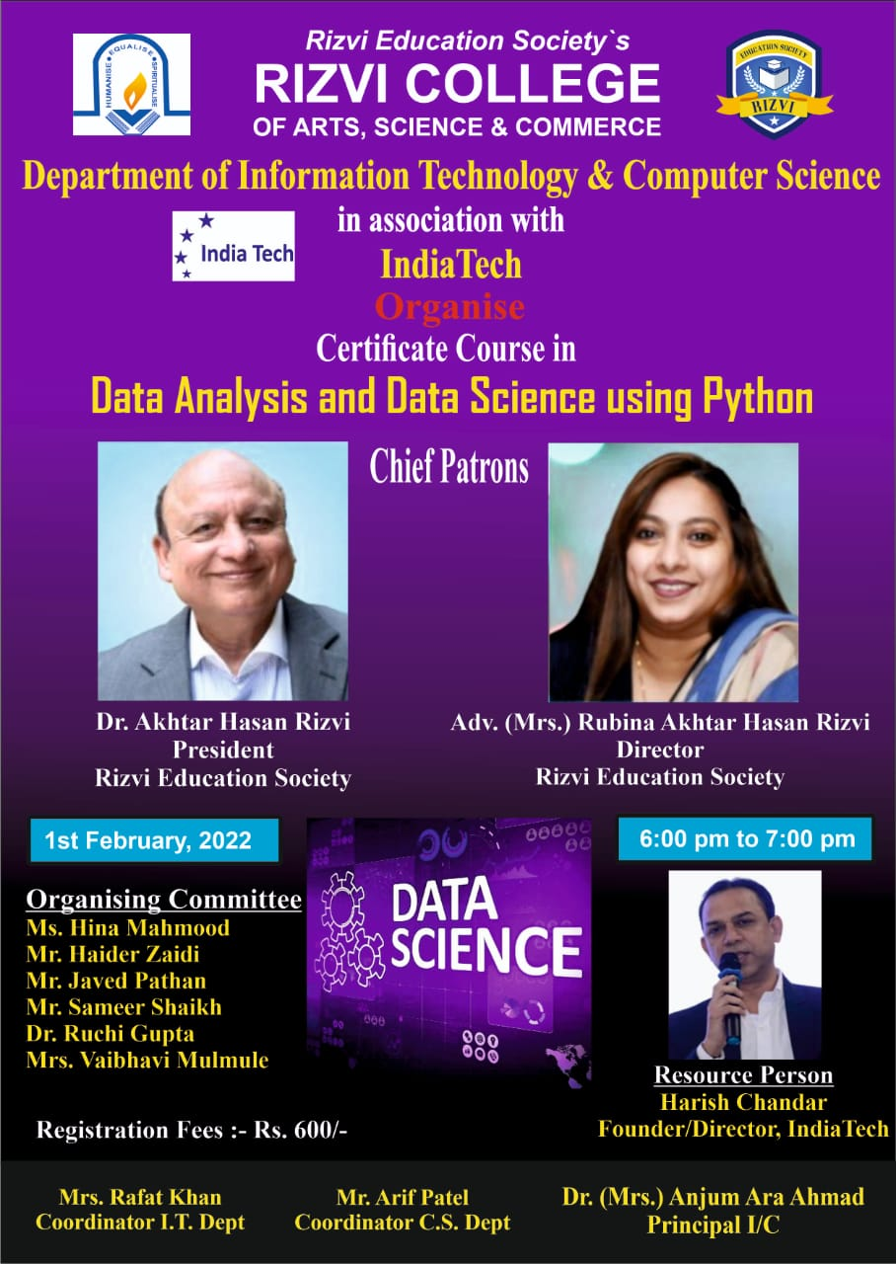

- Free Live Virtual training program on “Python for Data Science” was conducted by ExcelR under the MOU, for the duration of 42 hours, starting from 16th May 2022 (14 days, 3 hours daily ) from 11Am to 2Pm everyday, on weekdays. A total of 30 students registered for this course. Students were taught the concepts of Dictionaries, Data Handling, Numpy, Pandas, Data Wrangling, Data Visualization and Web Scraping

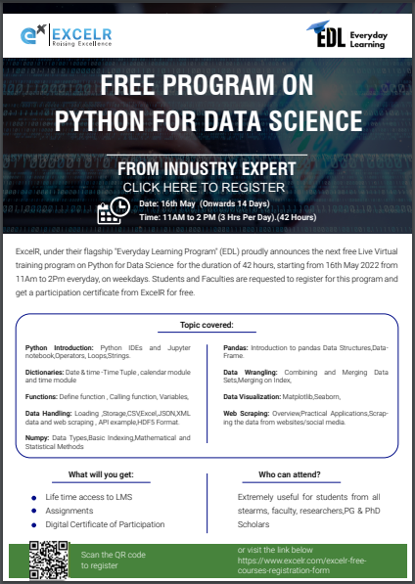

- Free Live Virtual training program on “Cloud Fundamentals” for the duration of 30 hours, starting from 20th June 2022 from 7PM to 9PM everyday, on weekdays. Topics covered were Cloud Basics, Azure, GCP and AWS. A total of 42 students registered for this course
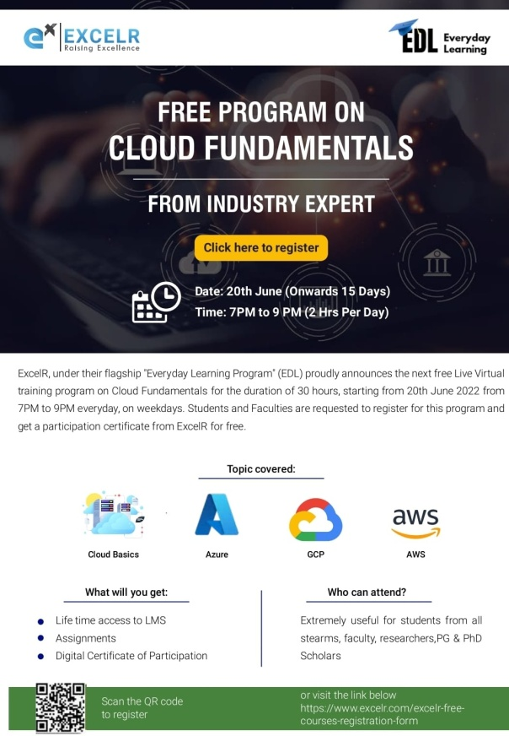

- Free Live Virtual training program on “Introduction to R programming and Tableau” for the duration of 30 hours, starting from 11th July 2022 from 7PM to 9PM every day, on weekdays. A total of 8 students registered for this course. Students were taught Data Types and data structures in R, Data Visualization, Data Connections, Organizing Data, Fields and Charts and Sharing Insights

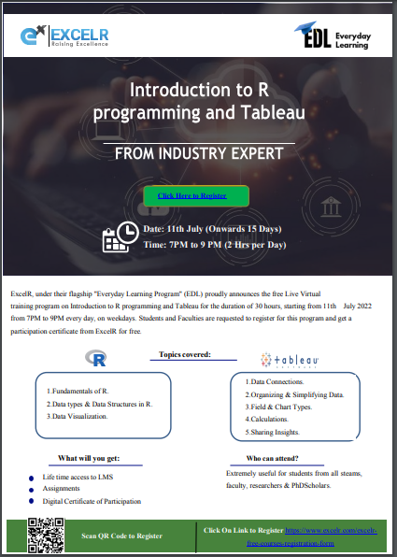
DEPT English
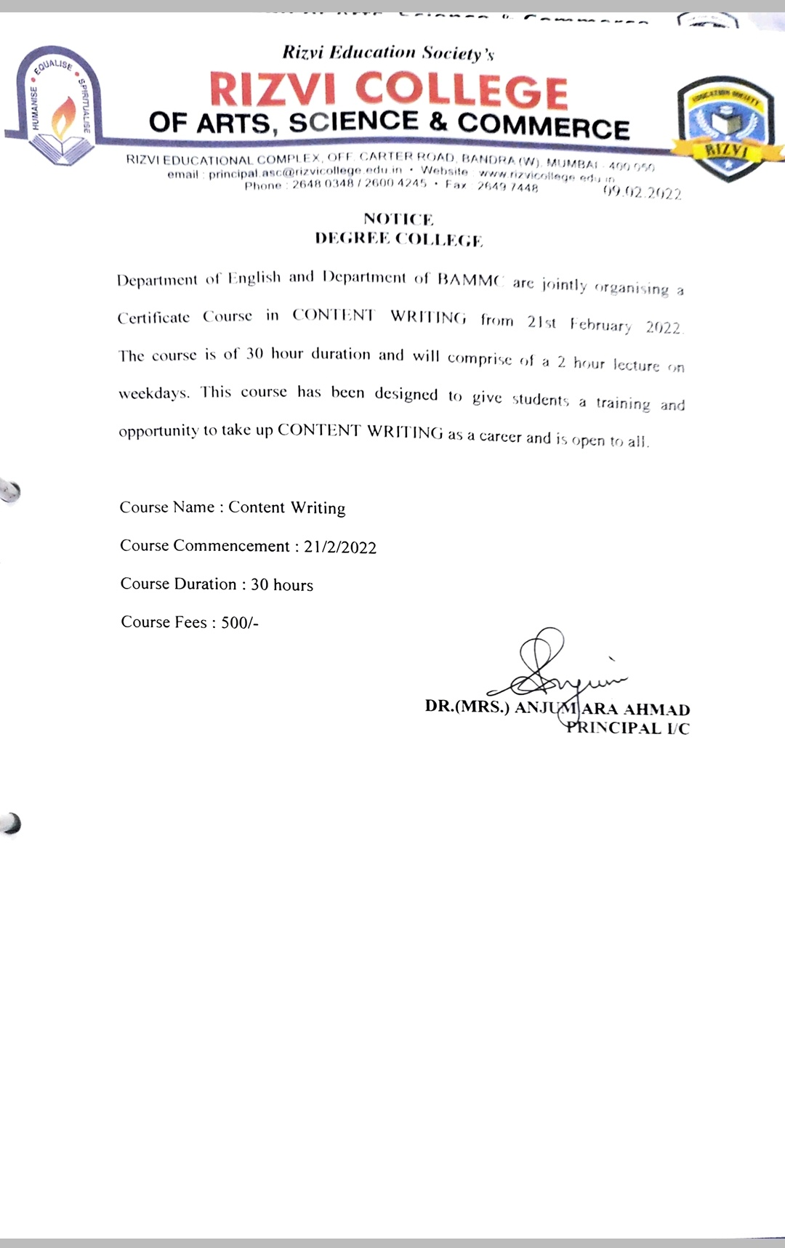
DEPT IT
- A Certificate Course of 30 hours on “Cyber Security and Ethical Hacking Level 1” was conducted from 11th February, 2022 to 11th April, 2022 by IndiaTech Pvt. Ltd. A total of 64 students attended this course

- A Certificate Course of 30 hours on “Cyber Security and Ethical Hacking Level 2” was conducted from 24th May, 2022 to 6th June, 2022 by IndiaTech Pvt. Ltd. A total of 34 students attended this course

- A Certificate Course of 30 hours on “Data Analysis and Data Science Using Python” was conducted from 23rd February, 2022 to 18th May, 2022 by IndiaTech Pvt. Ltd. A total of 38 students attended this course

- Free Live Virtual training program on “Python for Data Science” was conducted by ExcelR under the MOU, for the duration of 42 hours, starting from 16th May 2022 (14 days, 3 hours daily ) from 11Am to 2Pm everyday, on weekdays. A total of 30 students registered for this course. Students were taught the concepts of Dictionaries, Data Handling, Numpy, Pandas, Data Wrangling, Data Visualization and Web Scraping

- Free Live Virtual training program on “Cloud Fundamentals” for the duration of 30 hours, starting from 20th June 2022 from 7PM to 9PM everyday, on weekdays. Topics covered were Cloud Basics, Azure, GCP and AWS. A total of 42 students registered for this course

- Free Live Virtual training program on “Introduction to R programming and Tableau” for the duration of 30 hours, starting from 11th July 2022 from 7PM to 9PM every day, on weekdays. A total of 8 students registered for this course. Students were taught Data Types and data structures in R, Data Visualization, Data Connections, Organizing Data, Fields and Charts and Sharing Insights

- Online course on “C and C++” was conducted in association with Spoken Tutorial during July – December 2021 session. A total of 8 students enrolled in the course
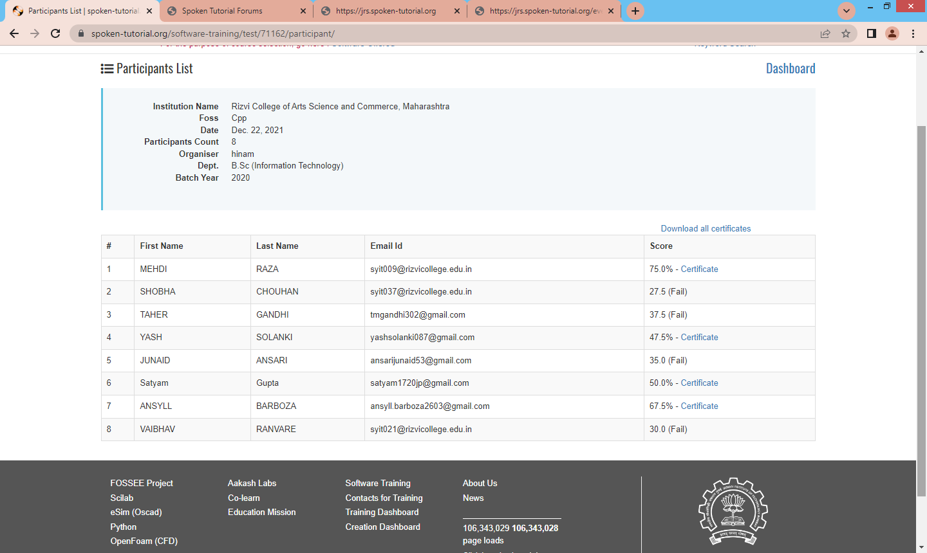
DEPT.ZOO
