2) Online orientation program Guide to accessing NLIST e-resources and other academic e-resources"
4th October, 2021 ( 62 students )

Dr. Rizvi Digital Library in its efforts to promote e-learning and reading and to celebrate the birth anniversary of our former President Dr. APJ Abdul Kalam, organised an online orientation program for second year and third year students on 4th October 2021 on Google meet platform . The topic was "Guide to accessing NLIST e-resources and other academic e-resources" . This session was taken by Dr. Sachin Vaidya Librarian of SVT College of Home Science, SNDT Women's University,Juhu; to train students for making maximum use of this resource of information and also to encourage students to read various online resources available.
Information was given on the features of NLIST database and the e resources available in the database. Practical demonstration was shown from registering to downloading the full text of e-books and articles. Also the students were made aware of the open access resources like DOAB , Open Textbook Library etc., available, which they can benefit from for their academic development. A total of 62 students attended the orientation program.

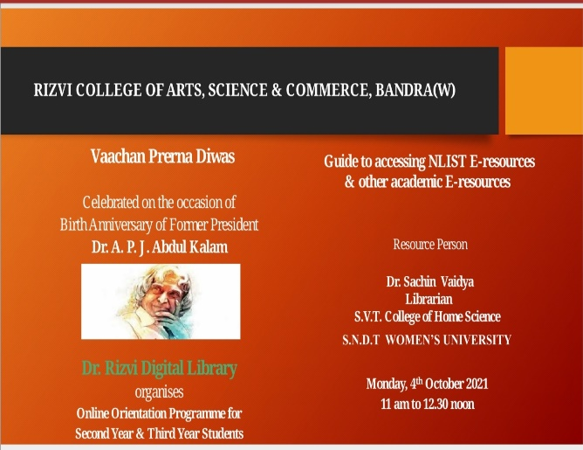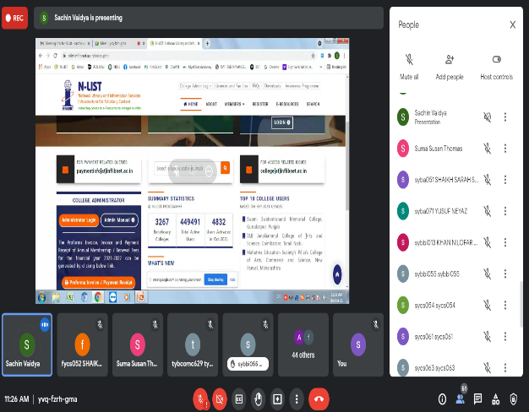
3) Library Orientation for Students
6th to 10th December, 2021 (294 students attended)
First year students were introduced to the library and its facilities. They were taught to access books through Web Opac and to access E-resources through library website www.librarydrdl.com
Offline session was conducted for students where they were informed about the library facilities. They were encouraged to and shown how to make use of our library e-resources through our library website. Various features of our website www.librarydrdl.com were explained to them.

